

*Journal of Geophysical Research - Atmospheres*

Supporting Information for

**An experimental investigation of kinetic fractionation of open-water evaporation over a large lake**

Wei Xiao1, Xuhui Lee1,2, Yongbo Hu1, Shoudong Liu1, Wei Wang1, Xuefa Wen3, Martin Werner4, and Chengyu Xie1

1Yale-NUIST Center on Atmospheric Environment & Collaborative Innovation Center on Forecast and Evaluation of Meteorological Disasters, Nanjing University of Information Science & Technology, Nanjing 210044, China, 2School of Forestry and Environmental Studies, Yale University, New Haven, Connecticut, USA, 3Key Laboratory of Ecosystem Network Observation and Modeling, Institute of Geographic Sciences and Natural Resources Research, Chinese Academy of Sciences, Beijing 100101, China, 4Alfred Wegener Institute, Helmholtz Centre for Polar and Marine Research, Bremerhaven, Germany

**Contents of this file**

Text S1. Detailed description of calibration of isotope observations

Text S2. Variations of the Craig-Gordon model

Figures S1 to S7

**Additional Supporting Information (Files uploaded separately)**

Data Set S1. The isotopic compositions of atmospheric water vapor measured over Lake Taihu.

**Introduction**

This supporting information introduces detailed description of the calibration procedure used for the isotope observations (Text S1) and variations of the Craig-Gordon model (Text S2). Figures on the analyzer performance (Figure S1 and S2), time series of the measured isotopic compositions of water vapor (Figure S5) and modeling results (Figure S3, S4, S6 and S7) are also included.

Text S1. Detailed description of calibration of isotope observations

**Calibration of the isotope ratios of water vapor isotope**

The method used to calibrate the vapor isotopic measurement is described by Lee et al. (2005, 2007) and Wen et al. (2008). For the reader’s convenience, we have reproduced the essential details here.

We denote $x_{a}$ and $x_{a}^{'}$ as the mixing ratios of the major and the minor isotopologue, respectively, in the ambient vapor sample recorded by the instrument, and $x_{s}$ and $x_{s}^{'}$ as the instrument recorded mixing ratios in the calibration vapor stream. The true mixing ratios are given by

, , ,  (S1)

where $g$ and $g'$ are gain correction factors on the major and minor isotopologues, respectively. By definition, the molar D/H or 18O/16O ratio of the ambient vapor *R* and that of the calibration vapor *Rs* are given by

,  (S2)

Manipulation of equations (S1) and (S2) yields a working formula for correcting the molar ratio of the ambient vapor from the molar ratio of the calibration vapor stream

 (S3)

where *Rs*, the molar ratio of the water feed to the vapor source, is known. In the actual field operation, two of the five calibration gases produced by the vapor source, with water vapor concentration higher and lower than that of the ambient vapor, are selected to make calibration during each calibration cycle, in order to reduce a concentration dependence. If calibration vapor stream 1 (s,1) is selected, the calibrated vapor molar ratio *R*1 is given by

 (S4)

If calibration vapor stream 2 (s,2) is selected, the calibrated molar ratio is given by

 (S5)

These molar ratios are converted to the delta notation as

 (S6)

 (S7)

Next, a two-point interpolation is used to remove the concentration dependence as,

 (S8)

where *δ*V is the true 18O/16O ratio in delta notation of the ambient vapor, and *x*a, *x*s,1 and *x*s,2 are the molar mixing ratio of the ambient sample, calibration stream s1 and calibration stream s2, respectively. This two-point calibration yields an accuracy of 1.0 ‰ and 0.1 ‰ for *δ*D and *δ*18O, respectively, and a hourly precision of 0.5 ‰ and 0.3 ‰ for *δ*D and *δ*18O, respectively (Table 2; *Wen et al.* 2012a). Figure S1 shows an example of the concentration dependence of *δ*D and *δ*18O.

**Calibration of the isotope ratios of evaporation**

Let ${\hat{x}}_{a,1}^{}$ and ${\hat{x}}_{a,1}^{'}$ be the true molar mixing ratios of the major and the minor vapor isotopologue measured at height 1 above the water surface, and ${\hat{x}}_{a,2}^{}$ and ${\hat{x}}_{a,2}^{'}$ be the true molar mixing ratios at height 2. The molar D/H or 18O/16O ratio of evaporation is given according to the gradient-diffusion theory as

 (S9)

Let *g* and *g’* be the gain correction factors on the major and minor isotopologues, respectively. The relationships between the (uncalibrated) mixing ratio differences measured by the instrument and the true mixing ratio differences are:

 (S10)

 (S11)

Combining equations (S9) to (S11) gives,

 (S12)

Now let ${\hat{x}}_{s,1}^{}$ and ${\hat{x}}_{s,1}^{'}$ be the true molar mixing ratios of the major and the minor vapor isotopologue of calibration vapor stream s1, and ${\hat{x}}_{s,2}^{}$ and ${\hat{x}}_{s,2}^{'}$ be the true mixing ratios of the major and the minor vapor isotopologue of calibration vapor stream s2 $x_{s,1}^{}$ and $x_{s,1}^{'}$ be the uncalibrated molar mixing ratios of the major and the minor vapor isotopologue of calibration vapor stream s1, and $x_{s,2}^{}$ and $x_{s,2}^{'}$ be the uncalibrated mixing ratios of the major and the minor vapor isotopologue of calibration vapor stream s2. The uncalibrated mixing ratio differences between the two standard vapor streams are related to the true mixing ratio differences as,

 (S13)

 (S14)

Dividing equation (S14) by (S13), we obtain

 (S15)

where *R*S is the molar ratio of the water feed to the vapor source. Combining equations (S12) and (S15), we obtain the working formula for determining the evaporation molar ratio with the gradient diffusion method,

 (S16)

Here the two standards are chosen to bracket the two ambient measurements. Use of two standards instead of one removes the concentration dependence.

We conducted a Monte Carlo simulation to quantify error propagation through equation (S16). The analysis was done for a typical water vapor mixing ratio difference of 1000 ppm and a mixing ratio of 20,000 ppm. An ensemble of 800,000 members were used and were assumed to follow a normal distribution with hourly instrument standard deviations of 4.265, 0.004883, and 0.002969 ppm for H216O, H218O and HDO, respectively. The standard deviation of the evaporation isotope ratio calculated with equation (S16) is 5.2 ‰ and 20.1 ‰, for H218O and HDO, respectively, after the top and bottom 1% of the ensemble have been removed. This analysis assumes that errors in the eight variables in equation (S16) are totally random and uncorrelated with one another. In actual measurements, they are actually correlated, so the actual *δ*E precisions should be better than those obtained with the Monte Carlo simulation. For example, a laboratory test on the gradient-diffusion system yields a precision of 1.4 ‰ for *δ*18O (Lee et al., 2007). Additionally, an estimate of the *δ*E precision can be obtained from the data in Figures 5 and S3. During DOY 226 to 226.5, atmospheric conditions were relatively constant with time (Figure S5), and as a result the true evaporation deltas should also be relatively constant. The standard deviation of *δ*E over this period is 1.6 ‰ and 5.6 ‰ for H218O and HDO, respectively.

**Text 2. Variations of the Craig-Gordon model**

The Craig-Gordon model appears in several different forms in the published literature, mostly due to different ways of expressing the kinetic effect. The form used in this study (equation (5)) is a common usage in oceanic and global climate model studies (Dee et al., 2015; Hoffmann et al., 1998; Merlivat & Jouzel, 1979; Pfahl et al., 2012; Risi et al., 2010) and by terrestrial ecologists [e.g. the review by Yakir & Sternberg, 2000]. Since the humidity influence is expressed explicitly in equation (5), the kinetic factor *ε*k is independent of humidity.

In some lake studies, the Craig-Gordon model is expressed as

 (S17)

(e.g., Gibson et al., 2016; Horita et al., 2008), where *h*m is relative humidity at the top of the laminar layer. In equation (S17), the kinetic fractionation factor $ε_{k}$ is given by

 (S18)

where *C*k represents the deviation from unity of the H218O (or HDO) to H216O diffusivity ratio and is in the per mil unit, and the weighting factor *θ* describes the effect of the humidity difference between the water surface and the free air layer on isotopic fractionation. A frequently-used value for 18O *C*k is 14.2 ‰ (Gibson et al., 2016, 2017; Horita et al., 2008; Skrzypek et al., 2015).

In the original Craig-Gordon evaporation model, there are three discrete layers between the water surface and the free air layer, i.e. the liquid to air interface, a laminar air layer and a turbulent layer. Due to the admixture of evaporated vapor with the vapor in the air layer aloft, relative humidity referenced to the water surface temperature decreases with increasing height: it is unity in the saturated liquid-air interface, decreases to *h*m at the top of the laminar layer and to *h*t at the top of the turbulent layer, and remains constant with height in the free air layer. The correction factor *θ* is expressed as

 (S19)

where *r*m is the diffusion resistance in the laminar layer and *r*t is the total diffusion resistance. This factor is close to unity over small lakes since little evaporation contribution is expected (Gibson et al., 1996, 1998; Isokangas et al., 2015) and is less than unity over large lakes, with a value of 0.88 for the North American Great Lakes (Gat et al., 1994) and around 0.5 for the eastern Mediterranean Sea (Gat et al., 1996). To implement this formulation (equations (S17) to (S19)), the input variables of the model should be measured at a reference height in the free air layer above the water surface.

A comparison of equation (5) and equations (S17 – S19) reveals that

 (S20)

if *h* in equation (5) is measured at the reference height in the free air layer. In our analysis, we assumed that equation (5) holds when we used the lake kinetic parameter. But because our humidity measurement was made in the turbulent layer, strictly speaking the correct kinetic factor for use in equation (5) should be

 (S21)

so that equation (5) is fully consistent with equation (S17). In other words, equations (5) and (S17) differs by a factor *θ′*.

With regard to the height of the “free air” layer or the reference height, Horita et al. [2008] recommend this height to be about 10 – 20 m. The study by Gibson et al. (1999) suggests that the reference height be about 7 m. In the classic isotopic diffusion theory of Merlivat and Jouzel (1979), this height is set at 10 m. The same height is used in parameterizations of open-water evaporation (Garratt, 1992) and trance gas fluxes between lakes and the atmosphere (Cole & Caroca, 1998). Using the Monin-Obukhov similarity profile relation, we found that *θ′* = 0.94 for our lake, meaning that the humidity measured at the height of 3.5 m should be slightly higher than that at the standard reference height of 10 m. With this adjustment, the *ε*k value would decrease to 13.3 ‰ (for 18O), not small enough to explain the disagreement between the model prediction and the observation.

We note that the LK *ε*k is based on the turbulent parameterization that the diffusion resistance in the laminar layer above the water surface is proportional to the inverse of the molecular diffusivity raised to the *n*th power (Kim & Lee, 2011) and that the exponent *n* is equal to 0.5. The end result is that the kinetic factor is reduced by half from the molecular value, to 14.2 ‰ for H218O (Gonfiantini, 1986).

The fact that the LK *ε*k does not work indicates that the effect of turbulence on the kinetic fractionation has not been fully accounted for by the LK *ε*k parameterization.

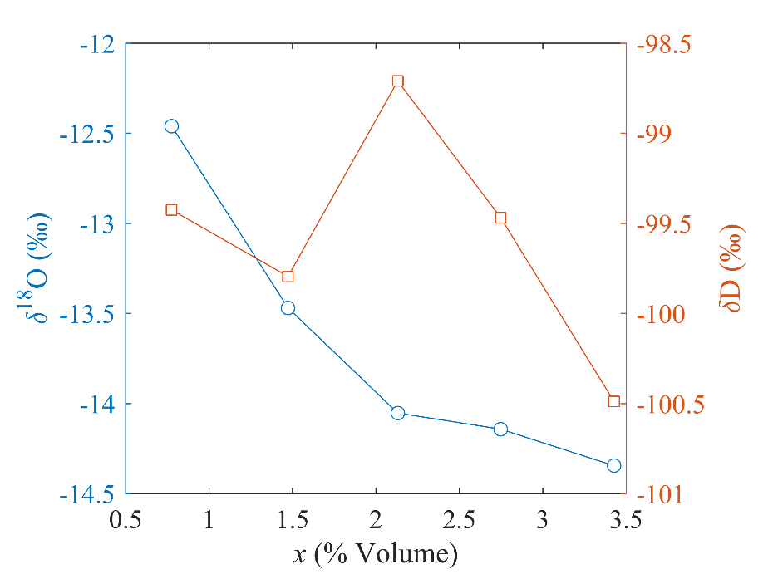

Figure S1. An example showing the concentration dependence of the vapor delta values. Here the measurement at the upper intake was calibrated against one calibration stream at a time without the two-point interpolation. The data used for this plot comes from the calibration cycle shown in Figure 4.

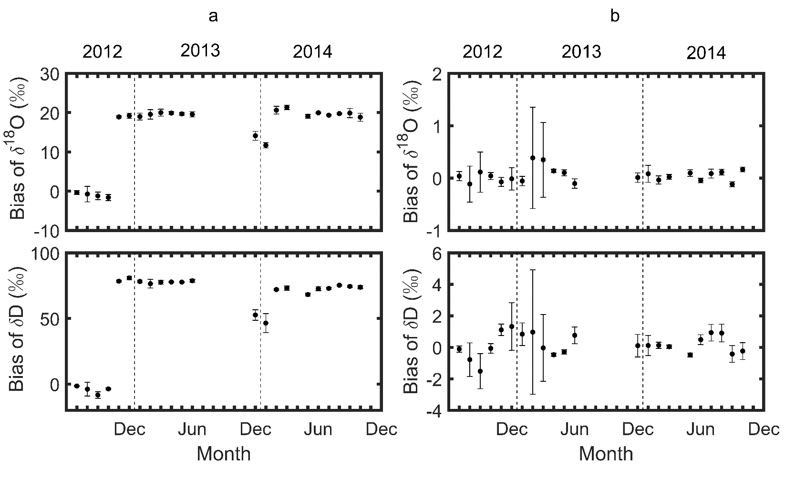

Figure S2. Instrument bias errors before (panels a) and after in-situ calibration (panels b). Each data point represents the mean of 5-days of measurement of vapor stream s3 generated by the source. Calibration was performed using vapor streams s2 and s4 whose concentrations were higher and lower, respectively, than that of s3.

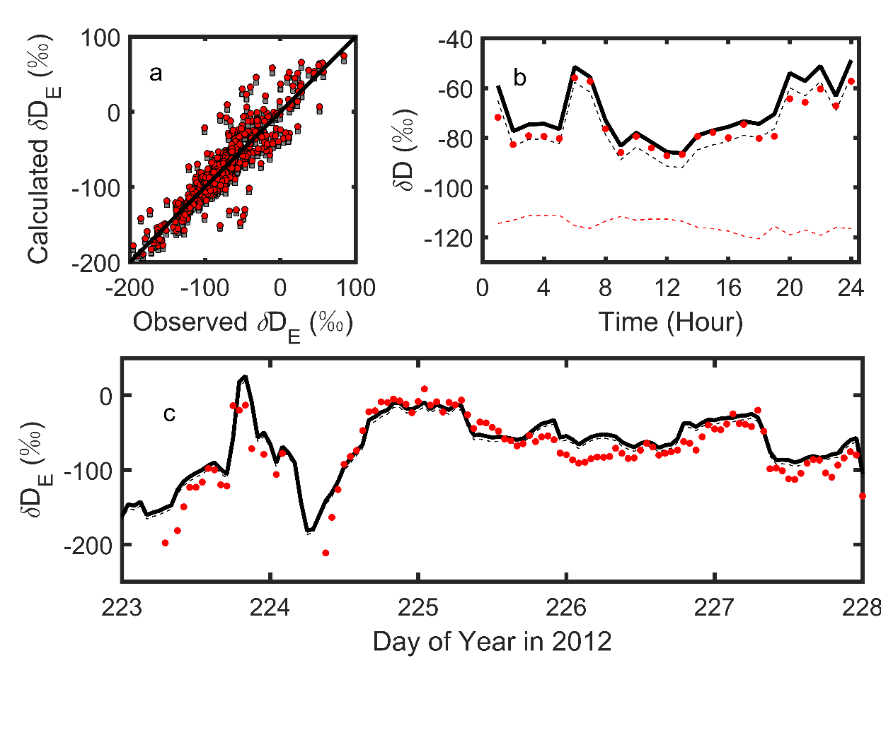

Figure S3. HDO isotopic composition of evaporation at Lake Taihu in open fetch conditions. a, Comparison of the Craig-Gordon model calculations against the observations (red dots, model with OS εk; grey squares, model with LK εk; solid line: 1:1 match). b, Diurnal composite of δDE calculated with the OS εk (solid line) and the LK εk scheme (black dashed line), the observed δDE (red dots) and the observed HDO composition of water vapor (red dashed line). c, Time series of δDE calculated with the OS εk (solid line) and the LK εk (dashed line), and the observed δDE (red dots).

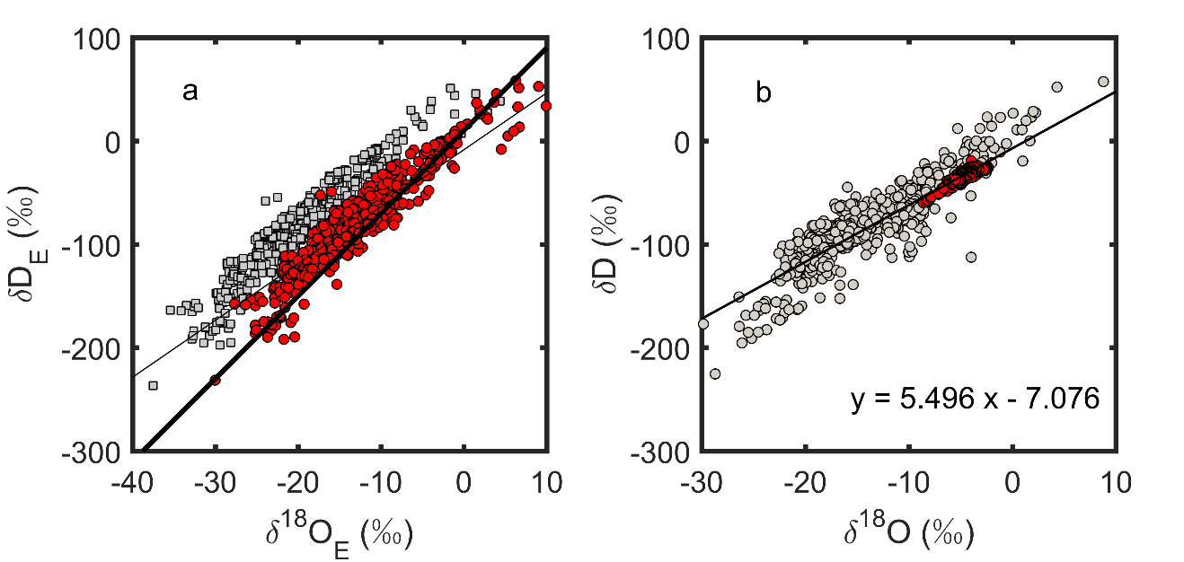

Figure S4. a, Comparison of the Craig-Gordon model calculation with the local evaporation line (thin solid line, *δ*D = 5.502δ18O – 8.577). Each symbol represents one hourly mean of *δ*E (red dots, model with OS *ε*k; grey squares, model with LK *ε*k). The GMWL is shown as the thick solid line. b, Local evaporation line based on observed hourly isotope composition of evaporation (grey dots) and that of the lake water (red dots). The regression line is based on both data groups.

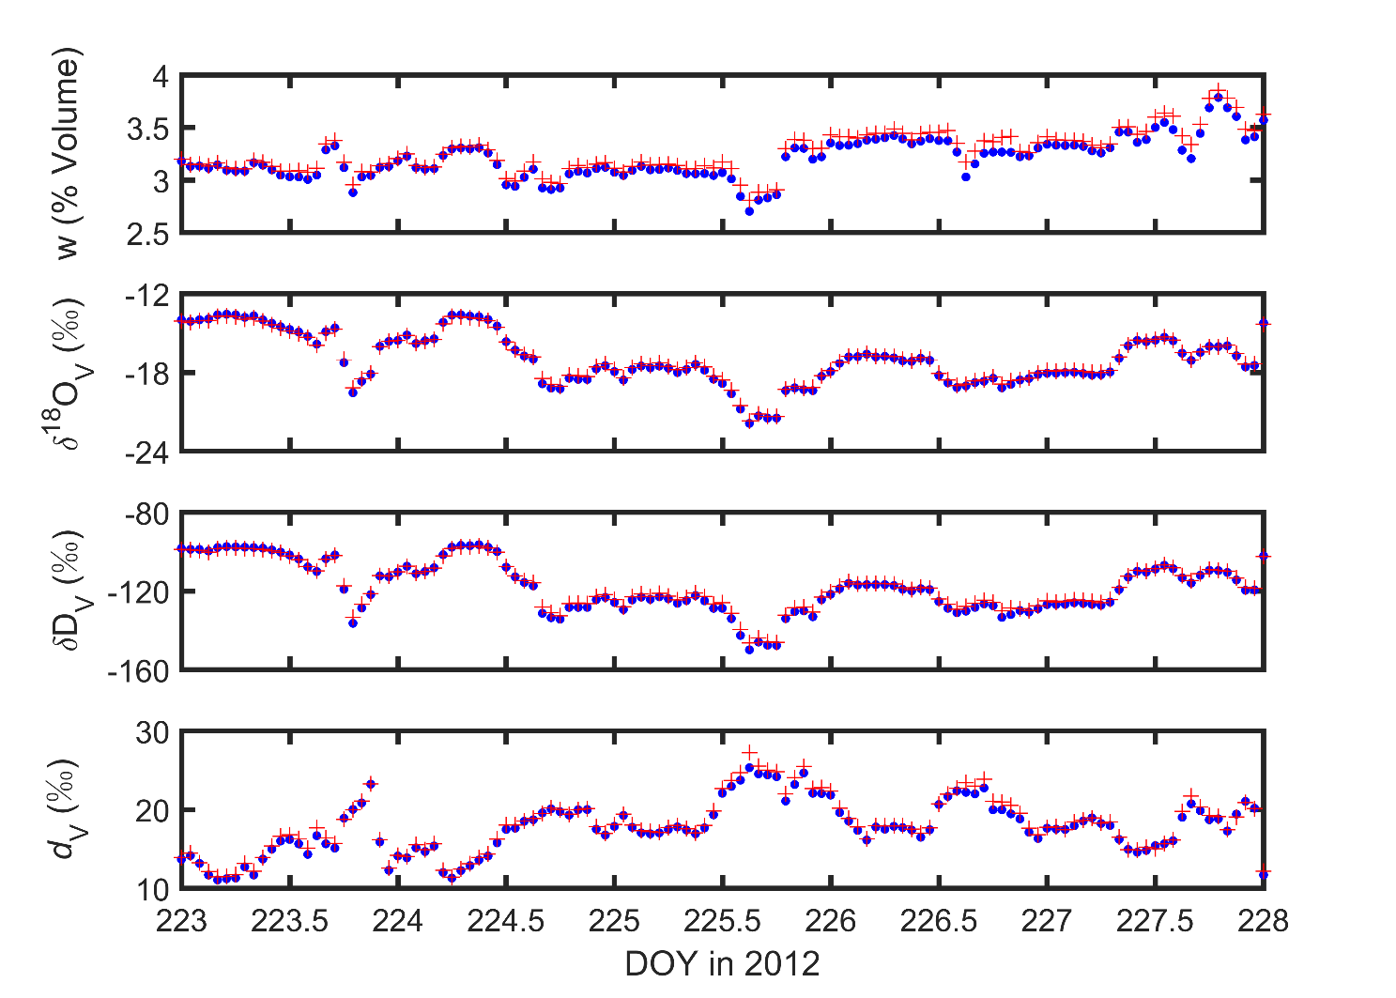

Figure S5. Time series of the water vapor mixing ratio, *δ*DV, *δ*18OV and *d*V during the same period of Figure 5d (blue dots, at 3.5 m height; red crosses, at 1.1 m height).

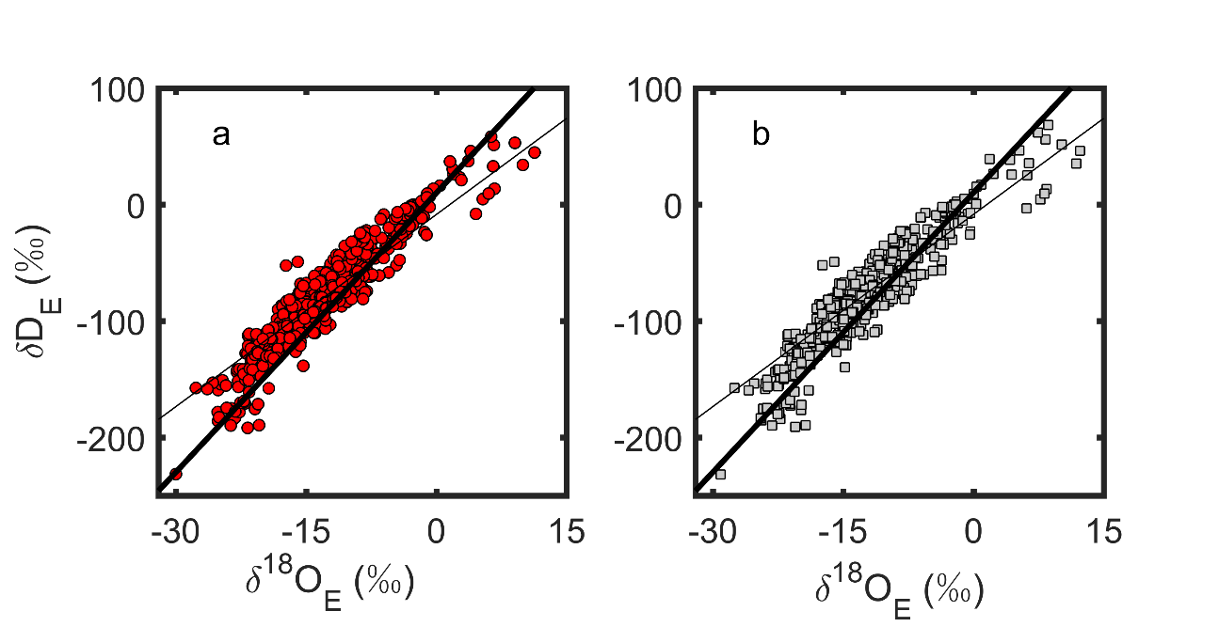

Figure S6. Comparison of the Craig-Gordon model calculation using *δ*V at two different heights. Each symbol represents one hourly mean of *δ*E (red dots, model with *δ*V at 1.1 m; grey squares, model with *δ*V at 3.5 m). The GMWL and LEL are shown as the thick solid line and thin solid line respectively.

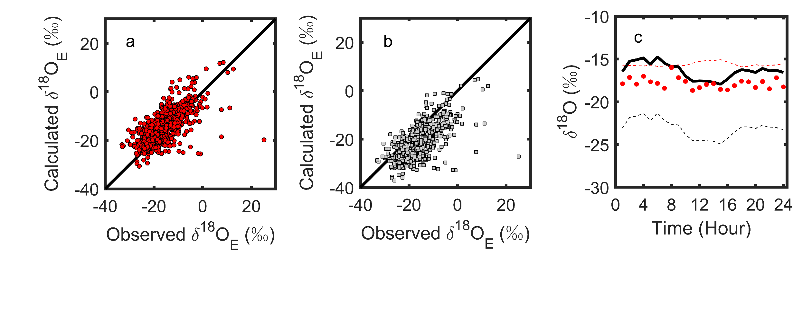

Figure S7. H218O isotopic composition of Lake Taihu evaporation in short fetch conditions (wind directions 315 – 135o). a, Comparison of the Craig-Gordon model calculations with the OS *ε*k against the observations; b, Comparison of the Craig-Gordon model calculations with the LK *ε*k against the observations; c, Diurnal composite of *δ*18OE calculated with the OS *ε*k (solid line) and the LK *ε*k (dashed line), and the observed *δ*18OE (red dots). Solid lines in panels a and b are 1:1 match.

Data Set S1. The isotopic compositions of atmospheric water vapor measured over Lake Taihu.