Journal of Atmospheric and Oceanic Technology; https://doi.org/10.1175/JTECH-D-17-0085.s1.

A Meta-Analysis of Open-Path Eddy Covariance Observations of Apparent CO₂ Flux in Cold Conditions in FLUXNET

Liming Wang, Xuhui Lee, Wei Wang, Xufeng Wang, Zhongwang Wei, Congsheng Fu, Yunqiu Gao, Ling Lu, Weimin Song, Peixi Su, and Guanghui Lin

Supplemental Material

© Copyright 2017 American Meteorological Society
Permission to use figures, tables, and brief excerpts from this work in scientific and educational works is hereby granted provided that the source is acknowledged. Any use of material in this work that is determined to be “fair use” under Section 107 of the U.S. Copyright Act or that satisfies the conditions specified in Section 108 of the U.S. Copyright Act (17 USC §108) does not require the AMS’s permission. Republication, systematic reproduction, posting in electronic form, such as on a website or in a searchable database, or other uses of this material, except as exempted by the above statement, requires written permission or a license from the AMS. All AMS journals and monograph publications are registered with the Copyright Clearance Center (http://www.copyright.com). Questions about permission to use materials for which AMS holds the copyright can also be directed to the AMS Permissions Officer at permissions@ametsoc.org. Additional details are provided in the AMS Copyright Policy statement, available on the AMS website
(http://www.ametsoc.org/CopyrightInformation).
Supplementary information for JTECH-D-17-0085.s1

Table S1. Summary statistics of the relationship between wintertime CO₂ flux (F_{c,a}, umol m⁻² s⁻¹) and sensible heat (H, W m⁻²) and meteorological conditions at the 64 eddy flux sites.
Site ID | Slope | R² | Air temperature  (℃) | Absolute humidity  (g m⁻³) | Equipment | Vegetation type | Reference
CA-Qcu | −0.003 | 0.23 | −15.47 |  | LI-7500+CSAT3 | ENF | Giasson(2006)
CA-SF1 | −0.017 | 0.68 | −14.99 | 1.76 | LI-7500+CSAT3 | ENF | Amiro (2010)
CA-SF2 | −0.011 | 0.73 | −16.82 | 1.44 | LI-7500+CSAT3 | ENF | Amiro (2010)
CA-SF3 | −0.014 | 0.85 | −14.39 | 1.71 | LI-7500+CSAT3 | OSH | Amiro (2010)
CA-TP1 | 0.0002 | 0.09 | −6.51 |  | LI-7500+CSAT3 | ENF | Peichl (2010)
CN-Arou | −0.005 | 0.86 | −12.74 | 3.23 | LI-7500+CSAT3 | GRA | Liu et al. (2011)
CN-Cha | −0.004 | 0.92 | −12.57 | 1.27 | LI-7500+CSAT3 | ENF | Yu et al. (2006b)
CN-Cng | −0.008 | 0.98 | −13.48 | 1.04 | LI-7500+CSAT3 | GRA | Yu et al. (2006b)
CN-Dan | −0.002 | 0.95 | −8.41 | 1.02 | LI-7500+CSAT3 | GRA | Yu et al. (2006b)
CN-Du2 | 0.001 | 0.70 | −14.21 | 1.16 | LI-7500+CSAT3 | GRA | Zhang et al. (2007)
CN-Gebi | −0.007 | 0.90 | −6.34 | 6.46 | LI-7500+CSAT3 | BAR | Liu et al. (2011)
CN-Ha2 | −0.005 | 0.84 | −13.09 | 0.97 | LI-7500+CSAT3 | OSH | Zhang et al. (2016)
CN-HaM | −0.001 | 0.26 | −13.68 | 1.04 | LI-7500+CSAT3 | GRA | Zhang et al. (2016)
CN-Huazhaizi | −0.003 | 0.84 | −10.39 |  | LI-7500+CSAT3 | ENF | Liu et al. (2011)
CN-Hunhelin | −0.014 | 0.95 | −7.73 | 4.25 | LI-7500+CSAT3 | ENF | Liu et al. (2011)
CN-Huyanlin | −0.011 | 0.94 | −8.00 | 0.93 | LI-7500+CSAT3 | DBF | Liu et al. (2011)
CN-Kub_f | −0.010 | 0.94 | −8.41 | 1.47 | LI-7500+CSAT3 | DBF | This study
CN-Kub_s | −0.014 | 0.98 | −8.45 | 1.43 | LI-7500+CSAT3 | OSH | This study
CN-Shenshawo | −0.015 | 0.70 | −7.21 | 0.19 | LI-7500+CSAT3 | BAR | Liu et al. (2011)
CN-Sw2 | 0.008 | 0.74 | −17.57 | 0.97 | LI-7500+CSAT3 | GRA | Shao et al. (2013)
CN-Xilinguole | −0.002 | 0.11 | −13.15 |  | LI-7500+CSAT3 | GRA | Yu et al. (2006b)
CN-Yucheng | −0.015 | 0.73 | −3.30 |  | LI-7500+CSAT3 | CRO | Yu et al. (2006b)
DE-SfN | −0.018 | 0.77 | −2.89 | 3.88 | LI-7500+CSAT3 | WET | Hommeltenberg et al. (2014)
DE-RuS | −0.037 | 0.94 | −2.05 |  | LI-7500+CSAT3 | CRO | Schmidt et al. (2012)
IT-CA3 | −0.003 | 0.65 | −1.39 | 3.34 | LI-7500+CSAT3 | DBF | Stojanov et al. (2013)
IT-Noe | −0.007 | 0.86 | −1.15 | 3.94 | LI-7500+CSAT3 | OSH | Marras et al. (2011)
IT-Tor | −0.010 | 0.93 | −5.64 | 2.11 | LI-7500+CSAT3 | GRA | Migliavacca et al. (2011)
US-Bn2 | 0.0004 | 0.02 | −11.62 | 1.49 | LI-7500+CSAT3 | DBF | Liu et al. (2005)
US-Bn3 | −0.004 | 0.40 | −11.12 | 1.49 | LI-7500+CSAT3 | OSH | Liu et al. (2005)
US-Br1 | −0.008 | 0.24 | −9.50 | 2.24 | LI-7500+CSAT3 | CRO | Gilmanov et al. (2014)
US-Br3 | −0.004 | 0.38 | −9.41 | 2.23 | LI-7500+CSAT3 | CRO | Gilmanov et al. (2014)
US-CRT | 0.005 | 0.58 | −4.67 | 2.95 | LI-7500+CSAT3 | CRO | Chu et al. (2014)
US-ICh | 0.011 | 0.76 | −13.43 |  | LI-7500+CSAT3 | OSH | Euskirchen et al. (2012)
US-ICs | −0.008 | 0.82 | −14.53 |  | LI-7500+CSAT3 | WET | Euskirchen et al. (2012)
US-KUT | −0.005 | 0.64 | −11.22 | 2.99 | LI-7500+CSAT3 | GRA | Hiller et al. (2011)
US-Oho | −0.010 | 0.82 | −5.63 | 3.78 | LI-7500+CSAT3 | DBF | Noormets et al. (2008)
US-Wi2 | −0.012 | 0.49 | −7.04 | 3.01 | LI-7500+CSAT3 | ENF | Desai et al. (2008)
US-Wi3 | 0.003 | 0.02 | −7.30 | 3.51 | LI-7500+CSAT3 | DBF | Desai et al. (2008)
US-Wi4 | 0.001 | 0.01 | −4.80 | 3.64 | LI-7500+CSAT3 | ENF | Desai et al. (2008)
US-Wi5 | −0.051 | 0.34 | −5.39 | 3.42 | LI-7500+CSAT3 | ENF | Desai et al. (2008)
US-Wi9 | 0.013 | 0.68 | −7.48 | 3.93 | LI-7500+CSAT3 | ENF | Desai et al. (2008)
JP-SMF | −0.010 | 0.83 | −1.37 | 3.13 | LI-7500+DAT540 | ENF | Saigusa et al. (2010)
AT-Neu | −0.030 | 0.71 | −4.94 | 2.82 | LI-7500+Gill | GRA | Haslwanter et al. (2009)
AU-Tum | −0.023 | 0.41 | −1.40 |  | LI-7500+Gill | ENF | Van Gorsel et al. (2007)
CH-Cha | −0.014 | 0.38 | −3.36 | 3.59 | LI-7500+Gill | GRA | Zeeman et al. (2010)
CH-Fru | −0.007 | 0.64 | −4.41 | 3.35 | LI-7500+Gill | GRA | Zeeman et al. (2010)
FR-Fon | −0.009 | 0.81 | −2.34 |  | LI-7500+Gill | DBF | Delpierre et al. (2015)
IT-CA1 | 0.013 | 0.72 | −1.38 | 3.38 | LI-7500+Gill | DBF | Stojanov et al. (2013)
IT-La2 | 0.000 | 0.00 | −3.22 | 2.44 | LI-7500+Gill | ENF | Cava et al. (2008)
IT-Lav | −0.010 | 0.85 | −3.47 | 2.79 | LI-7500+Gill | ENF | Cava et al. (2008)
RU-Cok | −0.002 | 0.02 | −33.29 | -0.15 | LI-7500+Gill | OSH | Parmentier et al. (2011)
NL-Hor | −0.010 | 0.92 | −1.84 |  | LI-7500+Gill | ENF | Hendriks et al. (2008)
RU-Ha1 | −0.009 | 0.98 | −17.11 | 1.04 | LI-7500+Gill | GRA | Marchesini et al. (2007)
US-Ne1 | −0.003 | 0.23 | −7.09 | 2.52 | LI-7500+Gill | CRO | Suyker et al. (2004)
US-Ne2 | −0.002 | 0.22 | −7.50 | 2.52 | LI-7500+Gill | CRO | Suyker et al. (2004)
US-Ne3 | −0.004 | 0.24 | −7.09 | 2.46 | LI-7500+Gill | CRO | Suyker et al. (2004)
US-Sdh | 0.007 | 0.71 | −5.38 | 4.69 | LI-7500+Gill | GRA | Billesbach and Arkebauer (2012)
CN-Daman | −0.009 | 0.69 | −7.89 | 6.02 | LI-7500A+CSAT3 | CRO | Liu et al. (2011)
CN-Nongtian | −0.013 | 0.94 | −8.02 |  | LI-7500A+CSAT3 | CRO | Liu et al. (2011)
CN-Shidi | −0.017 | 0.90 | −6.30 | 9.02 | LI-7500A+CSAT3 | WET | Liu et al. (2011)
CN-Sidaoqiao | −0.003 | 0.50 | −7.52 | 5.61 | LI-7500A+CSAT3 | DBF | Liu et al. (2011)
IT-CA2 | −0.014 | 0.77 | −1.33 | 3.39 | LI-7500A+CSAT3 | CRO | Stojanov et al. (2013)
CN-Tarim | −0.017 | 0.75 | −7.14 | 4.04 | LI-7500A+Gill | DBF | Wang et al. (2016)
CN-Tarim2 | −0.019 | 0.94 | −8.08 | 2.20 | IRGASON+Gill | DBF | Wang et al. (2016)

Table S2. Detail information about the open-path eddy covariance sites used in this study. MAP: mean annual precipitation; MAT: mean annual temperature.
Site ID | Site name | MAP  (mm) | MAT  (°C) | Latitude (degrees) | Longitude  (degrees) | Years of data
CA-Qcu | Quebec - Eastern Boreal, Black Spruce/Jack Pine Cutover | 950 | 0.13 | 49.2671 | −74.0365 | 2001-2010
CA-SF1 | Saskatchewan - Western Boreal, forest burned in 1977 | 470 | 0.4 | 54.485 | −105.818 | 2003-3006
CA-SF2 | Saskatchewan - Western Boreal, forest burned in 1989 | 470 | 0.4 | 54.2539 | −105.878 | 2001-2006
CA-SF3 | Saskatchewan - Western Boreal, forest burned in 1998 | 470 | 0.4 | 54.0916 | −106.005 | 2001-2006
CA-TP1 | Ontario - Turkey Point 2002 Plantation White Pine | 1036 | 8 | 42.6609 | −80.5595 | 2002-2015
CN-Aro | Arou |  |  | 38.0473 | 100.4643 | 2008-2009
CN-Cha | Changbaishan |  |  | 42.4025 | 128.0958 | 2003-2005
CN-Cng | Changling |  |  | 44.5934 | 123.5092 | 2010
CN-Dan | Dangxiong |  |  | 30.4978 | 91.0664 | 2004-2005
CN-Du2 | Duolun grassland |  |  | 42.0467 | 116.2836 | 2007-2008
CN-Gebi | Heihe Gebi |  |  | 42.0012 | 101.1374 | 2014
CN-Ha2 | Haibei shrubland |  |  | 37.6086 | 101.3269 | 2003-2005
CN-HaM | Haibei Alpine |  |  | 37.3700 | 101.1800 | 2002-2004
CN-Huazhaizi | Heihe Huazhaizi |  |  | 38.7652 | 100.3186 | 2014
CN-Hunhelin | Heihe mixed forest |  |  | 41.9903 | 101.1335 | 2014
CN-Huyanlin | Heihe Populus euphratica |  |  | 41.9928 | 101.1236 | 2014
CN-Kub_f | Kubuqi Populus |  |  | 40.5383 | 108.6936 | 2006-2008
CN-Kub_s. | Kubuqi shrubland |  |  | 40.3808 | 108.5486 | 2006-2008
CN-Shenshawo | Heihe Shenshawo |  |  | 38.78917 | 100.4933 | 2014
CN-Sw2 | Siziwang Grazed |  |  | 41.7902 | 111.8971 | 2010-2012
CN-Xilinguole | Xilinguole |  |  | 44.1333 | 116.3000 | 2004-2005
CN-Yucheng | Yucheng |  |  | 36.9583 | 116.6406 | 2004-2005
DE-RuS | Selhausen Juelich | 700 | 10 | 50.86591 | 6.447169 | 2011-2014
DE-SfN | Schechenfilz Nord | 1127 | 8.6 | 47.80639 | 11.3275 | 2012-2014
IT-CA3 | Castel d'Asso 3 | 766 | 14 | 42.38 | 12.0222 | 2011-2013
IT-Noe | Arca di Noe - Le Prigionette | 588 | 15.9 | 40.60613 | 8.15146 | 2004-2014
IT-Tor | Torgnon | 2.9 | CO2−E/C | 45.84444 | 7.578055 | 2008-2013
US-Bn2 | Bonanza Creek, 1987 Burn site near Delta Junction |  |  | 63.9198 | −145.378 | 2002-2004
US-Bn3 | Bonanza Creek, 1999 Burn site near Delta Junction |  |  | 63.9227 | −145.744 | 2002-2004
US-Br1 | Brooks Field Site 10- Ames | 842 | 8.95 | 41.6915 | −93.6914 | 2005-2011
US-Br3 | Brooks Field Site 11- Ames | 847 | 8.9 | 41.9747 | −93.6936 | 2005-2011
US-CRT | Curtice Walter-Berger cropland | 849 | 10.1 | 41.6285 | −83.3471 | 2011-2013
US-ICh | Imnavait Creek Watershed Heath Tundra | 318 | −7.4 | 68.6068 | −149.296 | 2007-2011
US-ICs | Imnavait Creek Watershed Wet Sedge Tundra | 318 | −7.4 | 68.6058 | −149.311 | 2007-2011
US-KUT | KUOM Turfgrass Field | 777 | 7.9 | 44.995 | −93.1863 | 2005-2009
US-Oho | Oak Openings | 849 | 10.1 | 41.5545 | −83.8438 | 2004-2013
US-Wi2 | Intermediate red pine (IRP) |  |  | 46.6869 | −91.1528 | 2003
US-Wi3 | Mature hardwood (MHW) |  |  | 46.6347 | −91.0987 | 2002-2004
US-Wi4 | Mature red pine (MRP) |  |  | 46.7393 | −91.1663 | 2002-2005
US-Wi5 | Mixed young jack pine (MYJP) |  |  | 46.6531 | −91.0858 | 2004
US-Wi9 | Young Jack pine (YJP) |  |  | 46.6188 | −91.0814 | 2004-2005
JP-SMF | Seto |  |  | 35.2617 | 137.0788 | 2002-2006
AT-Neu | Neustift | 852 | 6.3 | 47.11667 | 11.3175 | 2003
AU-Tum | Tumbarumba |  |  | −35.6566 | 148.1517 | 2001-2014
CH-Cha | Chamau | 1136 | 9.5 | 47.21022 | 8.410444 | 2006-2012
CH-Fru | Früebüel | 1651 | 7.2 | 47.11583 | 8.537778 | 2006-2012
FR-Fon | Fontainebleau-Barbeau | 720 | 10.2 | 48.4764 | 2.780142 | 2005-2014
IT-CA1 | Castel d'Asso1 | 766 | 14 | 42.38041 | 12.02656 | 2011-2014
IT-La2 | Lavarone2 | 1150 | 7.2 | 45.9542 | 11.2853 | 2000-2002
IT-Lav | Lavarone | 1291 | 7.8 | 45.9562 | 11.28132 | 2003-2014
NL-Hor | Horstermeer | 800 | 10 | 52.24035 | 5.071301 | 2004-2011
RU-Cok | Chokurdakh | 232 | −14.3 | 70.82914 | 147.4943 | 2003-2013
RU-Ha1 | Hakasia steppe | 360 | 0.5 | 54.7252 | 90.0022 | 2002-2004
US-Ne1 | Mead - irrigated continuous maize site | 790 | 10.07 | 41.1651 | −96.4766 | 2001-2013
US-Ne2 | Mead - irrigated maize-soybean rotation site | 789 | 10.08 | 41.1649 | −96.4701 | 2001-2013
US-Ne3 | Mead - rainfed maize-soybean rotation site | 784 | 10.11 | 41.1797 | −96.4397 | 2001-2013
US-Sdh | Nebraska SandHills Dry Valley |  |  | 42.0693 | −101.407 | 2004-2009
CN-Daman | Daman |  |  | 38.8555 | 100.3722 | 2014
CN-Nongtian | Heihe cropland |  |  | 42.0048 | 101.1338 | 2014
CN-Shidi | Heihe wetland |  |  | 38.9751 | 100.4464 | 2014
CN-Sidaoqiao | Heihe Sidaoqiao |  |  | 42.0012 | 101.1374 | 2014
IT-CA2 | Castel d'Asso2 | 766 | 14 | 42.37722 | 12.02604 | 2011-2013
CN-Tarim | Tarim Populus euphratica |  |  | 40.4331 | 88.0261 | 2013
CN-Tarim2 | Tarim Populus euphratica |  |  | 40.4331 | 88.0261 | 2013

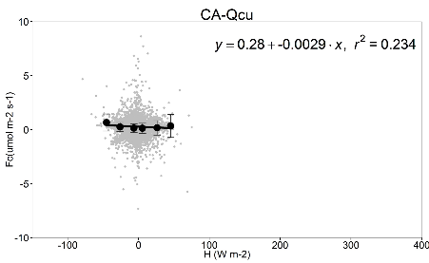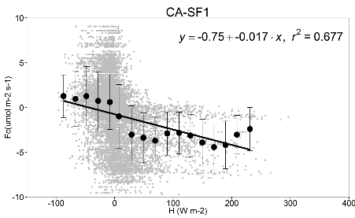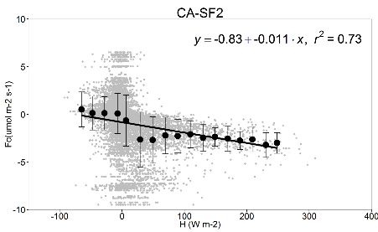
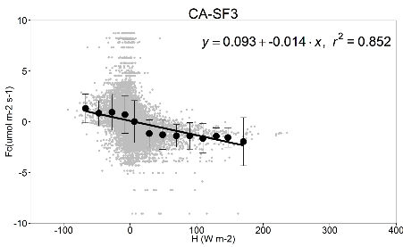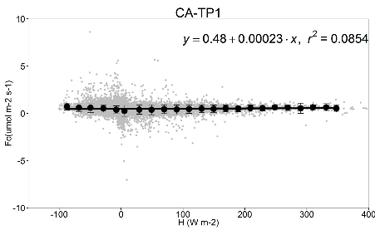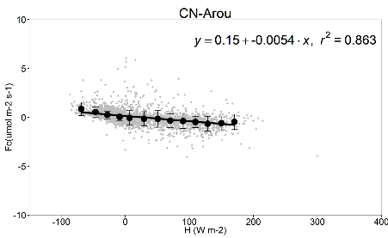
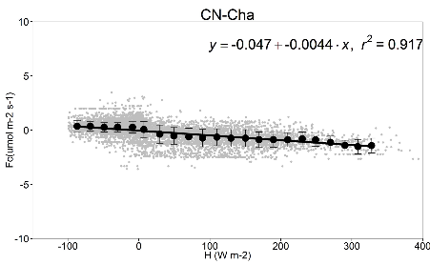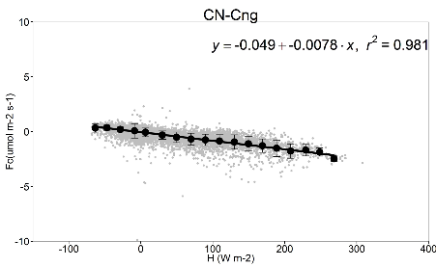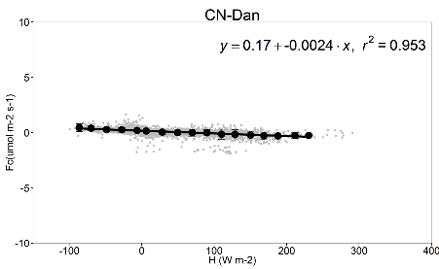
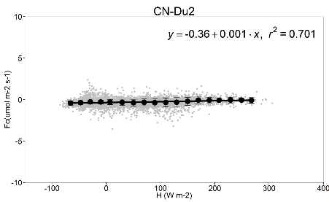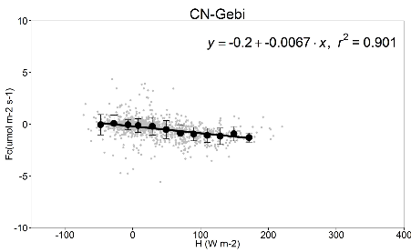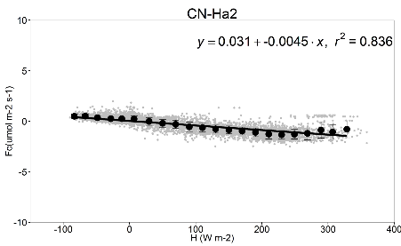
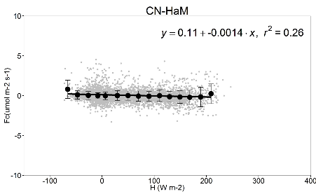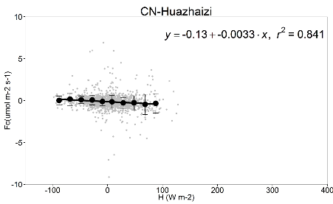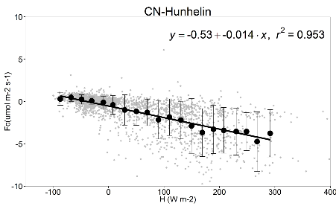
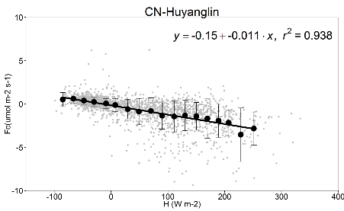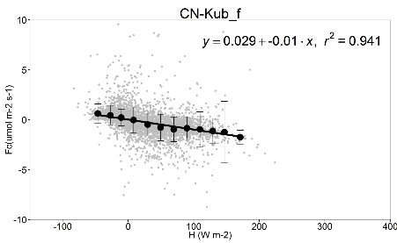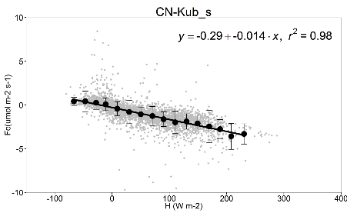
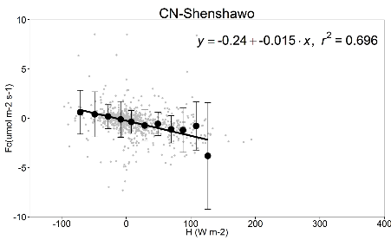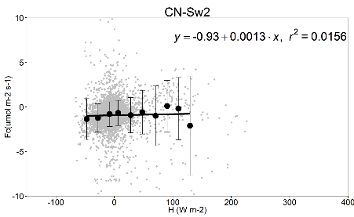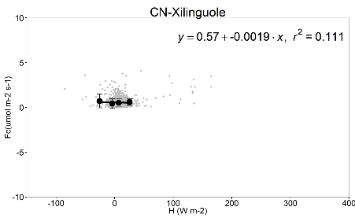

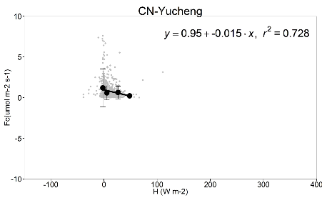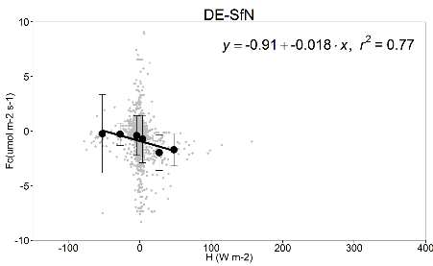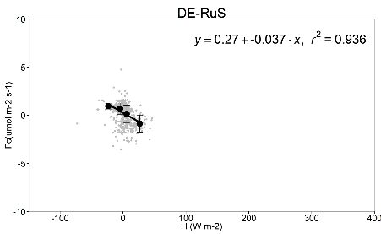
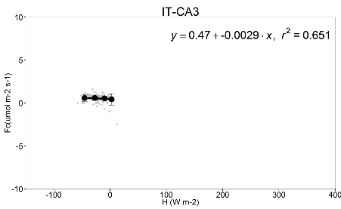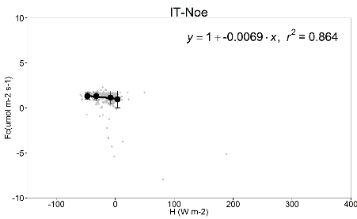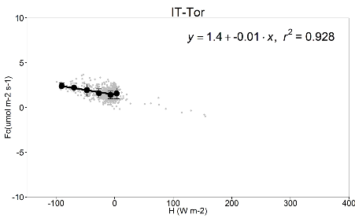
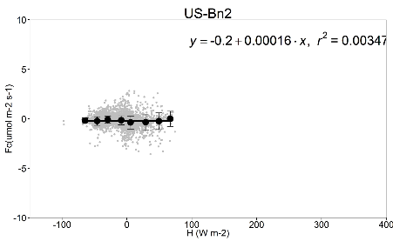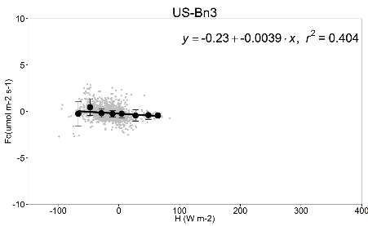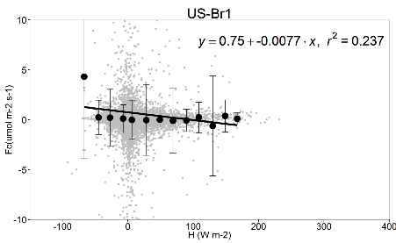
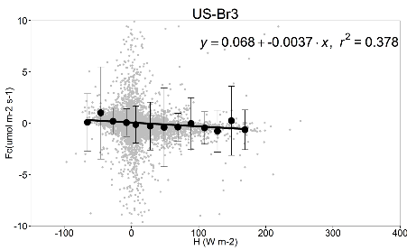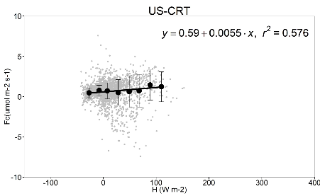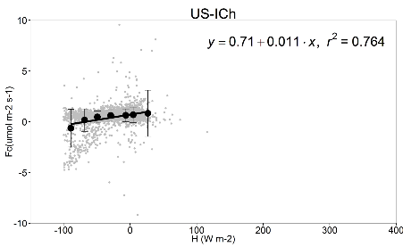
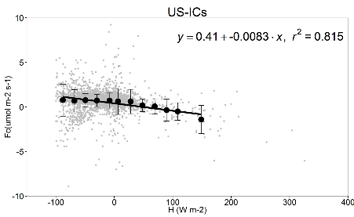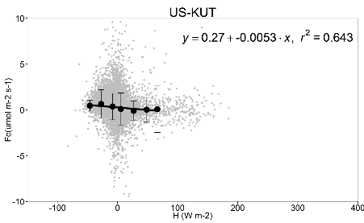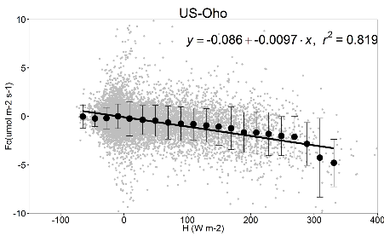
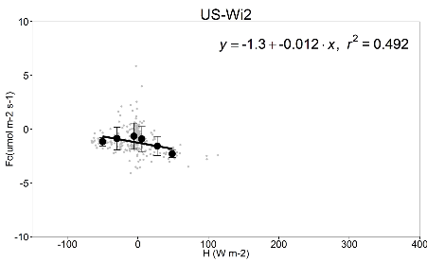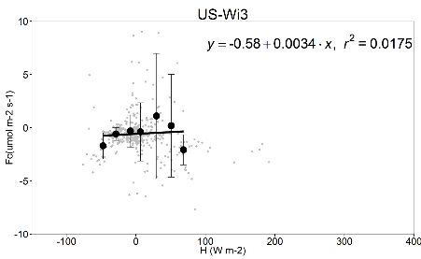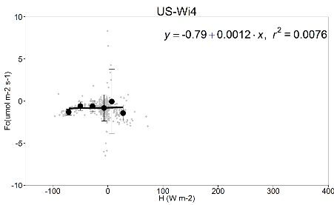
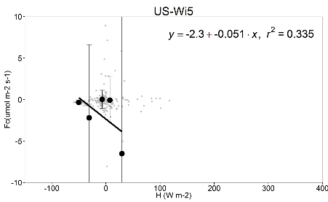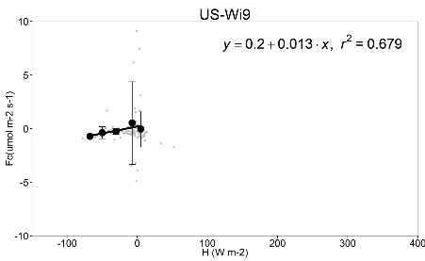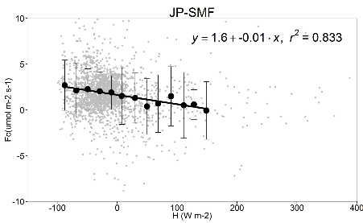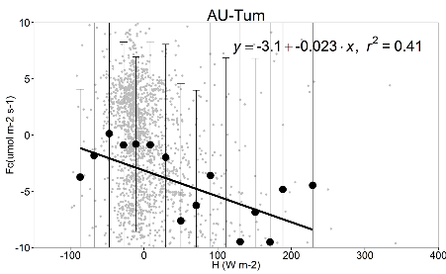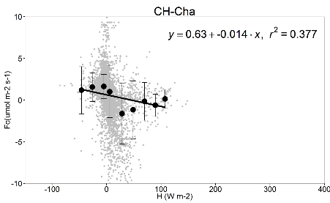
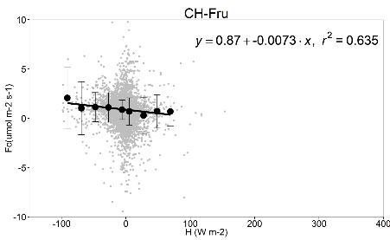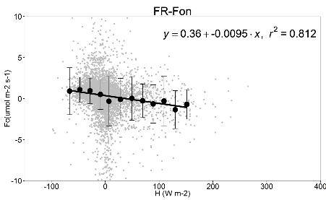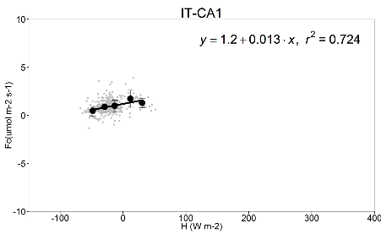
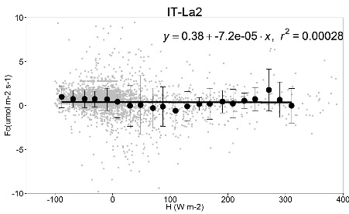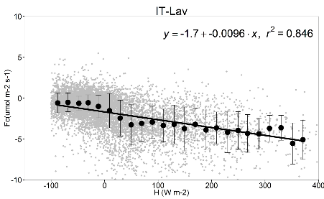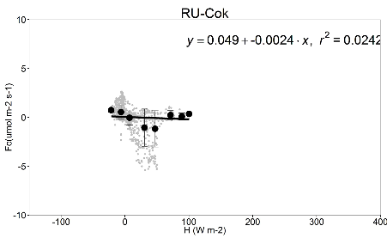
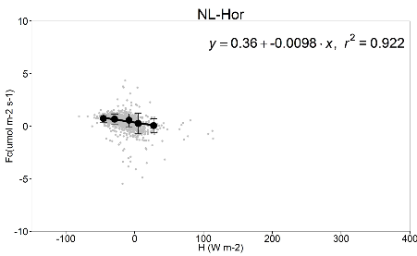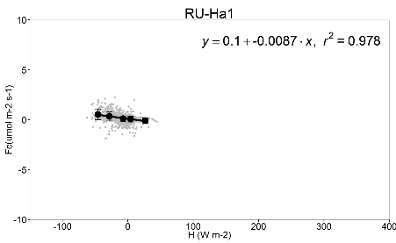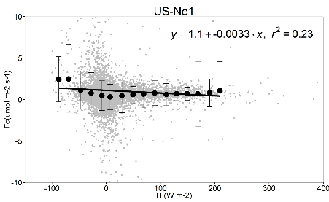
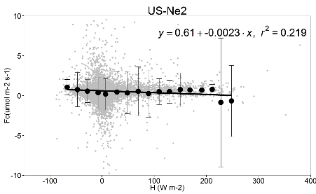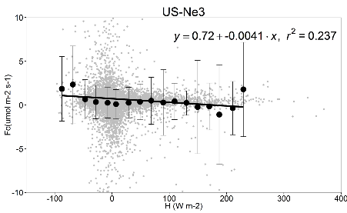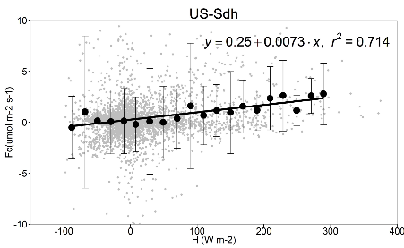
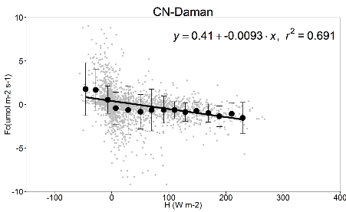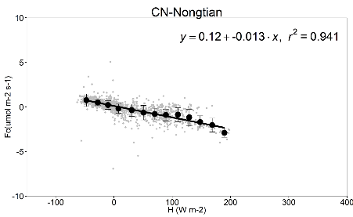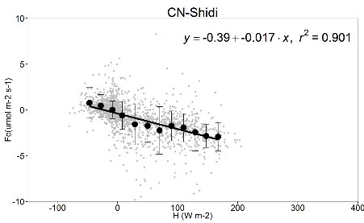
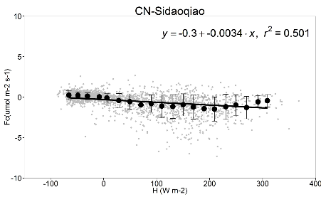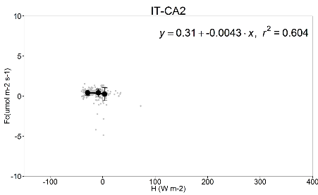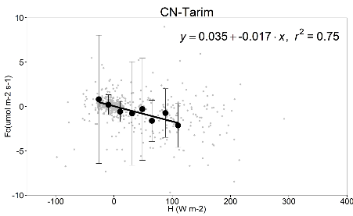
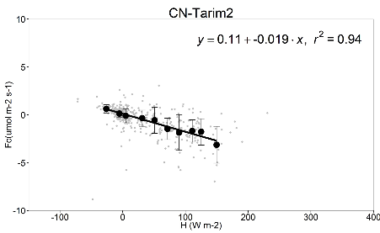
Figure S1. Relationship between wintertime CO₂ flux (F_{c}) and sensible heat (H). Grey dots represent half-hourly data, and black dots and error bars represent bin-average values and standard deviations.

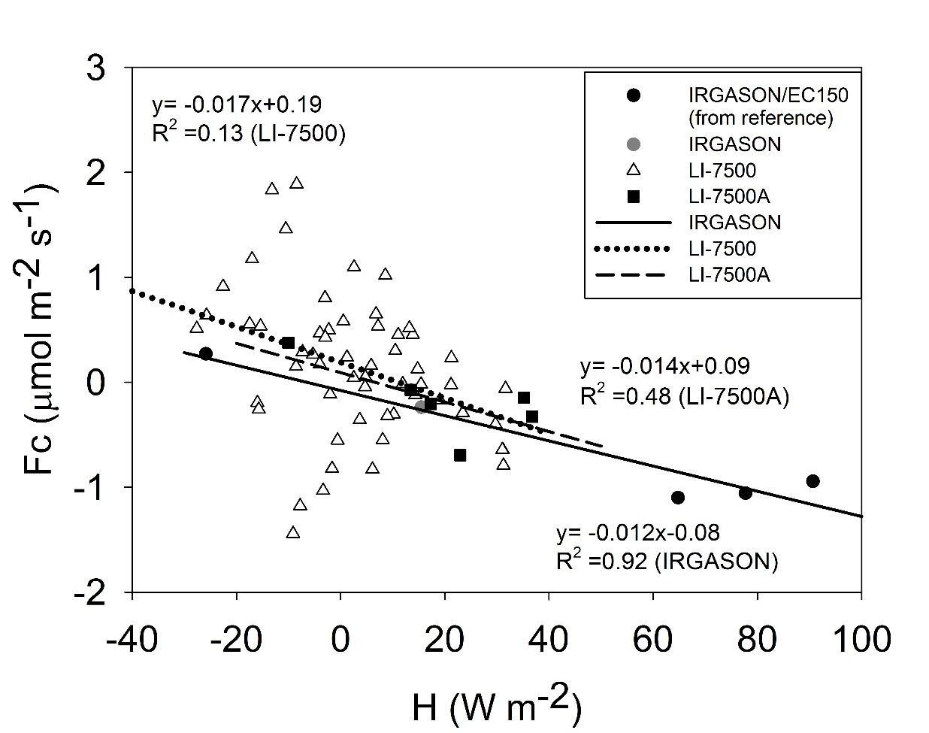
Figure S2. The site-mean CO₂ flux versus the site mean sensible heat flux. Different symbols represent different analyzer types.

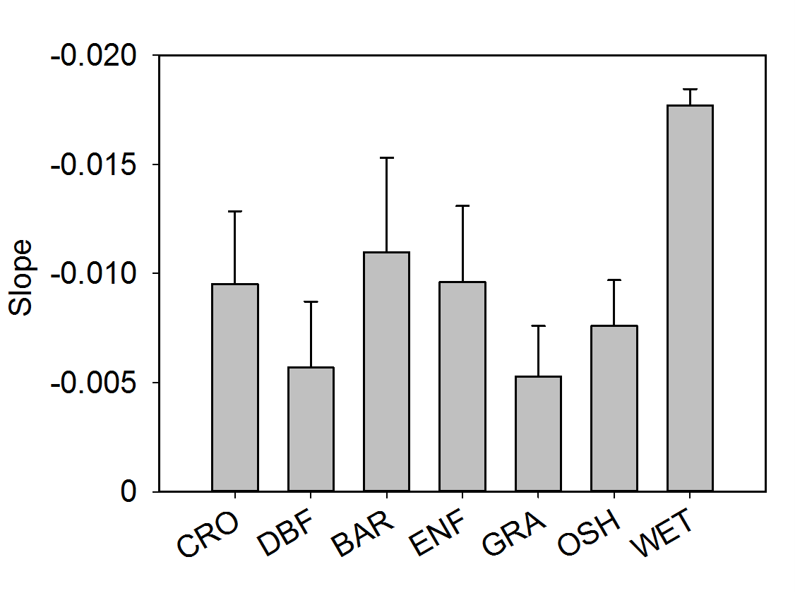
Figure S3. Comparison of the regression slope parameter b (μmol m⁻² s⁻¹ per W m⁻²) by vegetation type. Error bars are ± 1 standard error. CRO: Croplands (number of sites 11); DBF: Deciduous Broadleaf Forests (10); BAR: Barrens (2); ENF: Evergreen Needleleaf Forests (16); GRA: Grasslands (14); OSH: Open Shrublands (6); WET: Permanent Wetlands (2).

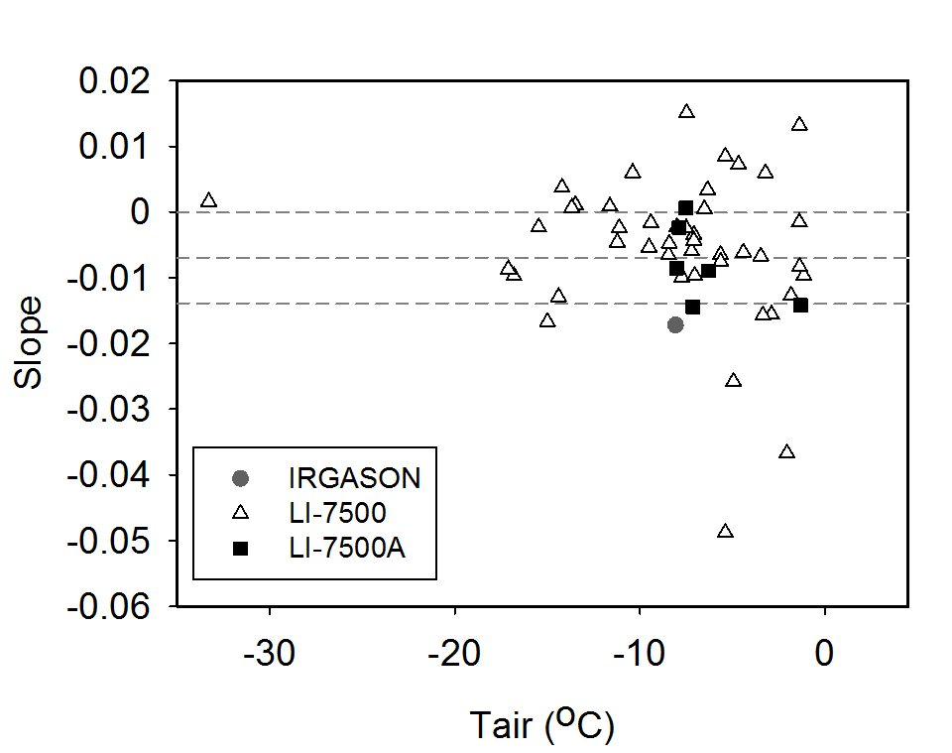
Figure S4. The regression slope parameter b (μmol m⁻² s⁻¹ per W m⁻²) with the effect of ρ_{c} biases excluded versus air temperature.

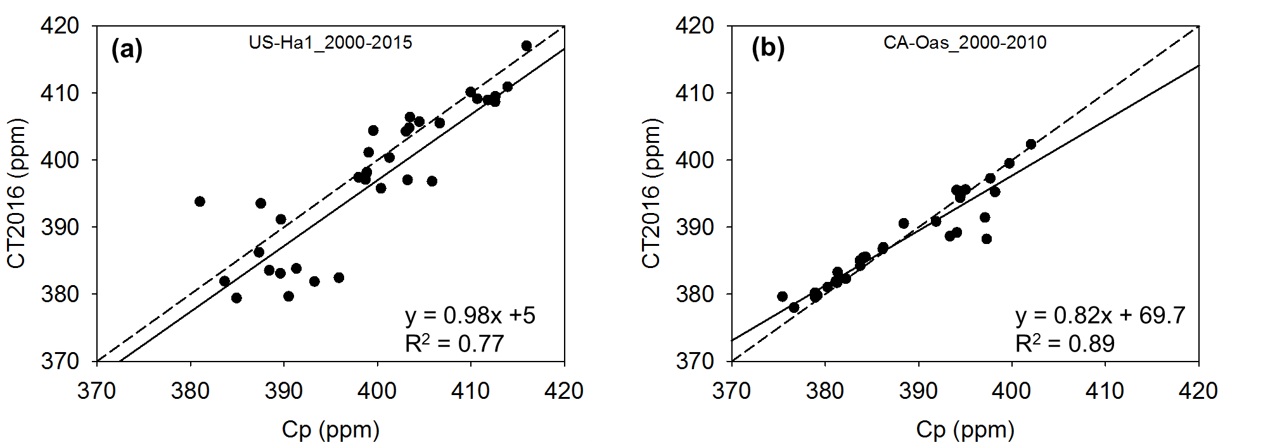
Figure S5. Comparison of the CarbonTracker surface monthly (December, January, February) mean CO₂ mole fraction against the monthly CO₂ mole fraction (in ppm) measured by close-path EC analyzers (Cp) at Harvard Forest, U.S. (panel a) and at Old Aspen, Canada (panel b). The periods of comparison are 2000-2015 for Harvard Forest and 2000-2010 for Old Aspen.
References
Amiro, B., 2010: Estimating annual carbon dioxide eddy fluxes using open-path analysers for cold forest sites. Agricultural and Forest Meteorology, 150, 1366-1372.
Billesbach, D. P., and T. J. Arkebauer, 2012: First long-term, direct measurements of evapotranspiration and surface water balance in the Nebraska SandHills. Agricultural and Forest Meteorology, 156, 104-110.
Cava, D., G. G. Katul, A. M. Sempreviva, U. Giostra, and A. Scrimieri, 2008: On the Anomalous Behaviour of Scalar Flux–Variance Similarity Functions Within the Canopy Sub-layer of a Dense Alpine Forest. Boundary-Layer Meteorology, 128, 33.
Chu, H., J. Chen, J. F. Gottgens, Z. Ouyang, R. John, K. Czajkowski, and R. Becker, 2014: Net ecosystem methane and carbon dioxide exchanges in a Lake Erie coastal marsh and a nearby cropland. J. Geophys. Res., Biogeosci., 119, 722-740.
Delpierre, N., D. Berveiller, E. Granda, and E. Dufrêne, 2015: Wood phenology, not carbon input, controls the interannual variability of wood growth in a temperate oak forest. New Phytol. 210, 459-470
Desai, A. R., and Coauthors, 2008: Influence of vegetation and seasonal forcing on carbon dioxide fluxes across the Upper Midwest, USA: Implications for regional scaling. Agricultural and Forest Meteorology, 148, 288-308.
Euskirchen, E., M. S. Bret-Harte, G. Scott, C. Edgar, and G. R. Shaver, 2012: Seasonal patterns of carbon dioxide and water fluxes in three representative tundra ecosystems in northern Alaska. Ecosphere, 3, 1-19.
Giasson, M. A., C. Coursolle, and H. A. Margolis, 2006: Ecosystem-level CO2 fluxes from a boreal cutover in eastern Canada before and after scarification. Agricultural and Forest Meteorology, 140, 23-40.
Gilmanov, T. G., and Coauthors, 2014: Productivity and Carbon Dioxide Exchange of Leguminous Crops: Estimates from Flux Tower Measurements. Agronomy Journal, 106, 545-559.
Haslwanter, A., A. Hammerle, and G. Wohlfahrt, 2009: Open- vs. closed-path eddy covariance measurements of the net ecosystem carbon dioxide and water vapour exchange: a long-term perspective. Agricultural and forest meteorology, 149, 291-302.
Hendriks, D., A. Dolman, M. Van Der Molen, and J. v. Huissteden, 2008: A compact and stable eddy covariance set-up for methane measurements using off-axis integrated cavity output spectroscopy. Atmospheric chemistry and Physics, 8, 431-443.
Hiller, R. V., J. P. McFadden, and N. Kljun, 2011: Interpreting CO2 Fluxes Over a Suburban Lawn: The Influence of Traffic Emissions. Boundary-Layer Meteorology, 138, 215-230.
Hommeltenberg, J., H. P. Schmid, M. Drösler, and P. Werle, 2014: Can a bog drained for forestry be a stronger carbon sink than a natural bog forest? Biogeosciences, 11, 3477-3493.
Liu, H., J. T. Randerson, J. Lindfors, and F. S. Chapin, 2005: Changes in the surface energy budget after fire in boreal ecosystems of interior Alaska: An annual perspective. Journal of Geophysical Research: Atmospheres, 110.
Liu, S., Z. Xu, W. Wang, Z. Jia, M. Zhu, J. Bai, and J. Wang, 2011: A comparison of eddy-covariance and large aperture scintillometer measurements with respect to the energy balance closure problem. Hydrology and Earth System Sciences, 15, 1291-1306.
Marchesini, L. B., D. Papale, M. Reichstein, N. Vuichard, N. Tchebakova, and R. Valentini, 2007: Carbon balance assessment of a natural steppe of southern Siberia by multiple constraint approach. Biogeosciences Discussions, 4, 165-208.
Marras, S., R. D. Pyles, C. Sirca, K. T. Paw U, R. L. Snyder, P. Duce, and D. Spano, 2011: Evaluation of the Advanced Canopy–Atmosphere–Soil Algorithm (ACASA) model performance over Mediterranean maquis ecosystem. Agricultural and Forest Meteorology, 151, 730-745.
Migliavacca, M., and Coauthors, 2011: Using digital repeat photography and eddy covariance data to model grassland phenology and photosynthetic CO2 uptake. Agricultural and Forest Meteorology, 151, 1325-1337.
Noormets, A., S. G. McNulty, J. L. DeForest, G. Sun, Q. Li, and J. Chen, 2008: Drought during canopy development has lasting effect on annual carbon balance in a deciduous temperate forest. New Phytol., 179, 818-828.
Parmentier, F., and Coauthors, 2011: Longer growing seasons do not increase net carbon uptake in the northeastern Siberian tundra. J. Geophys. Res., Biogeosci., 116.
Peichl, M., M. A. Arain, and J. J. Brodeur, 2010: Age effects on carbon fluxes in temperate pine forests. Agricultural and Forest Meteorology, 150, 1090-1101.
Saigusa, N., and Coauthors, 2010: Impact of meteorological anomalies in the 2003 summer on gross primary productivity in East Asia. Biogeosciences, 7, 641-655.
Schmidt, M., T. G. Reichenau, P. Fiener, and K. Schneider, 2012: The carbon budget of a winter wheat field: An eddy covariance analysis of seasonal and inter-annual variability. Agricultural and Forest Meteorology, 165, 114-126.
Shao, C., J. Chen, and L. Li, 2013: Grazing alters the biophysical regulation of carbon fluxes in a desert steppe. Environmental Research Letters, 8, 025012.
Stojanov, R., Z. Žalud, P. Cudlín, A. Farda, O. Urban, and M. Trnka, 2013: Global Change and Resilience. Climate of the Past, 9, 41-56.
Suyker, A. E., S. B. Verma, G. G. Burba, T. J. Arkebauer, D. T. Walters, and K. G. Hubbard, 2004: Growing season carbon dioxide exchange in irrigated and rainfed maize. Agricultural and Forest Meteorology, 124, 1-13.
Van Gorsel, E., R. Leuning, H. A. Cleugh, H. Keith, and T. Suni, 2007: Nocturnal carbon efflux: Reconciliation of eddy covariance and chamber measurements using an alternative to the u*‐threshold filtering technique. Tellus B, 59, 397-403.
Wang, W., and Coauthors, 2016: Performance evaluation of an integrated open-path eddy covariance system in a cold desert environment. Journal of Atmospheric and Oceanic Technology, 33(11), 2385-2399.
Yu, G.R., X.F. Wen, X.M. Sun, B. D. Tanner, X. Lee, and J.Y. Chen, 2006: Overview of ChinaFLUX and evaluation of its eddy covariance measurement. Agricultural and Forest Meteorology, 137, 125-137.
Zeeman, M. J., R. Hiller, A. K. Gilgen, P. Michna, P. Plüss, N. Buchmann, and W. Eugster, 2010: Management and climate impacts on net CO2 fluxes and carbon budgets of three grasslands along an elevational gradient in Switzerland. Agricultural and Forest Meteorology, 150, 519-530.
Zhang, T., and Coauthors, 2016: Ecosystem response more than climate variability drives the inter-annual variability of carbon fluxes in three Chinese grasslands. Agricultural and Forest Meteorology, 225, 48-56.
Zhang, W. L., S. P. Chen, J. Chen, L. Wei, X. G. Han, and G. H. Lin, 2007: Biophysical regulations of carbon fluxes of a steppe and a cultivated cropland in semiarid Inner Mongolia. Agricultural and Forest Meteorology, 146, 216-229.

