Journal of Geophysical Research: Atmospheres
Supporting Information for
Assessing the use of sub-grid land model output to study impacts of land cover change
Natalie M. Schultz¹*, Xuhui Lee^{1, 2}, Peter J. Lawrence³, David M. Lawrence³, Lei Zhao⁴
1: School of Forestry and Environmental Studies, Yale University, New Haven, Connecticut 06511, USA
2: Yale-NUIST Center on Atmospheric Environment, Nanjing University of Information Science & Technology, Nanjing, Jiangsu 210044, China
3: National Center for Atmospheric Research, Boulder, Colorado 80305, USA
4: Woodrow Wilson School of Public and International Affairs, Princeton University, Princeton, New Jersey 08544, USA

Contents of this file

Figures S1 to S6

Introduction
This document contains supplemental figures that include global maps of the PFT-level differences in air temperature and surface energy fluxes, the monthly and hourly surface temperature and energy fluxes for the PFTCOL and CTRL cases and the atmospheric forcing data for each of the three grid cells presented in the main text: tropical (grid center at 6.13ºN, 288.75ºE), temperate (35.34ºN,282.5ºE), and boreal (66.44ºN, 222.5ºE), and the relationship between PFT fraction and the difference in PFT-level variables between the two simulations. All figures were created following the methods described in the main text. Supplemental figures S1 and S2 present global maps of the data presented as zonal means in the main text. Figure S3 presents the atmospheric forcing data for each grid cell. Supplemental figures S4 to S6 present the monthly variations of surface variables from each simulation. Figures S7 to S9 present the hourly variations and differences between the two cases for each of the three grid cells. Figure S10 shows the difference in PFT-level variables as a function of grid cell fraction. Table S1 provides the PFT fractions in each of the three grid cells.

Figure S1. The spatial distribution of the difference in 2m surface air temperature for tree and grass PFTs between the PFTCOL and CTRL simulations. The zonal means are presented in Figure 1 in the main text.

Figure S2. The spatial distribution of the difference in net radiation, sensible heat flux, latent heat flux, and the ground heat flux for tree and grass PFTs between the PFTCOL and CTRL simulations. The zonal means are presented in Figure 2 in the main text.

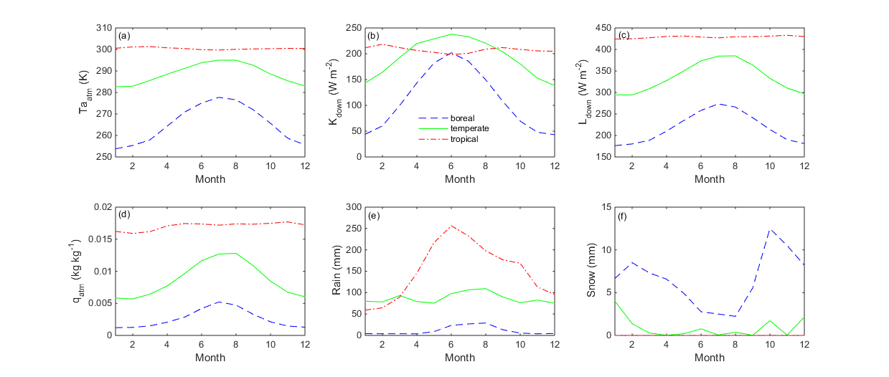

Figure S3. The 20-year (1991-2010) monthly mean values of the atmospheric forcing data (at reference height of 30m) used to drive CLM for each of the three grid cells.

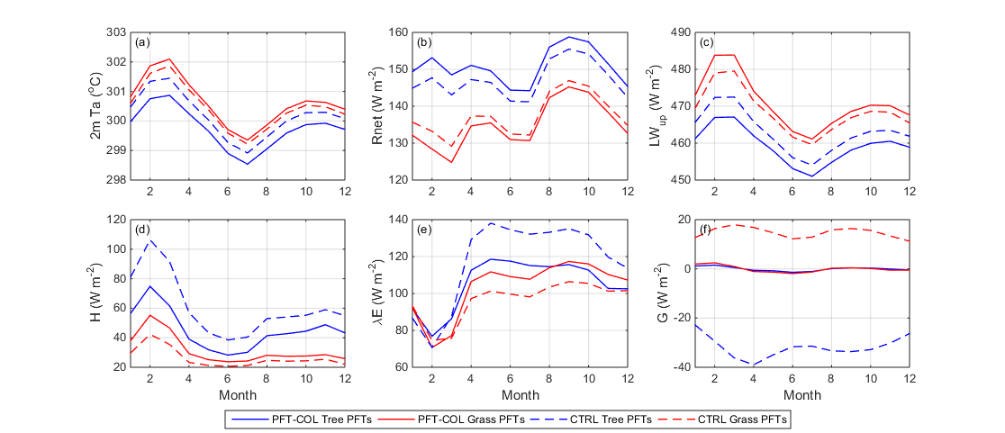

Figure S4. The monthly values of (a) 2-m air temperature, (b) net radiation, (c) emitted longwave radiation, (d) sensible heat flux, (e) latent heat flux, and (f) ground heat flux at the tree and grass PFT-level and grid cell-level for the tropical grid cell (6.13ºN, 288.75ºE). The monthly values are averaged over 20 years (1991-2010).

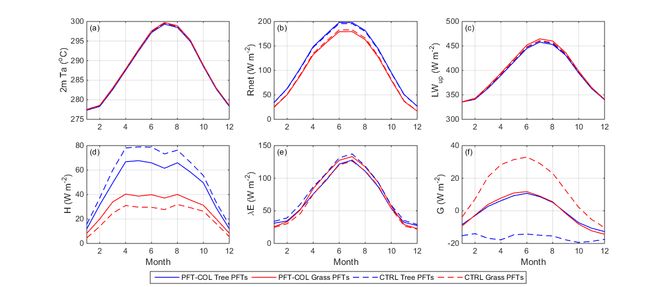

Figure S5. Same as Figure S1, but for the temperate grid cell (35.34ºN, 282.5ºE).
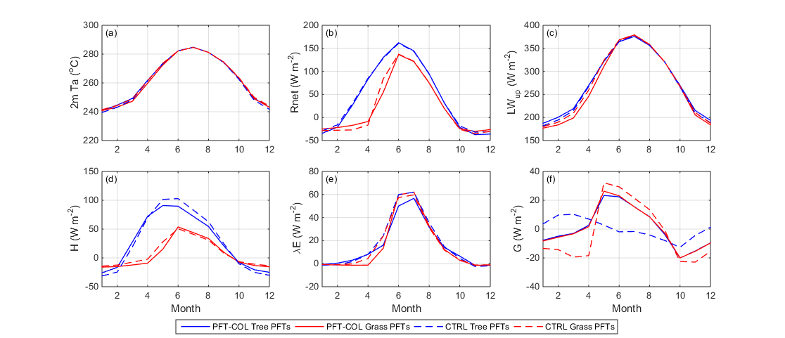

Figure S6. Same as Figure S1, but for the boreal grid cell (66.44ºN, 222.5ºE).
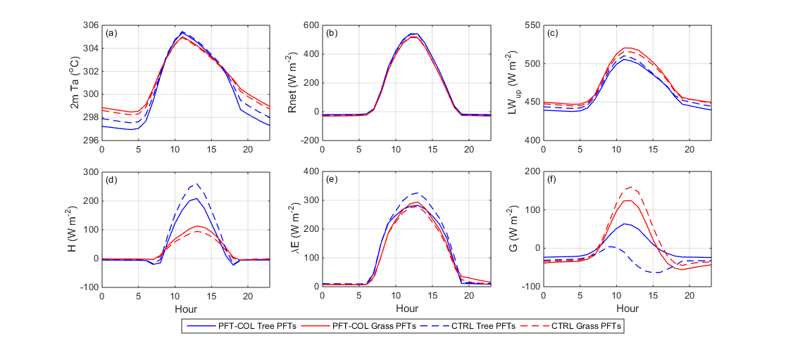

Figure S7a. The hourly values of (a) 2-m air temperature, (b) net radiation, (c) emitted longwave radiation, (d) albedo, (e) sensible heat flux, (f) latent heat flux, and (g) ground heat flux at the tree and grass PFT-level for the tropical grid cell (6.13ºN, 288.75ºE). The hourly values are averaged over one year (2010).

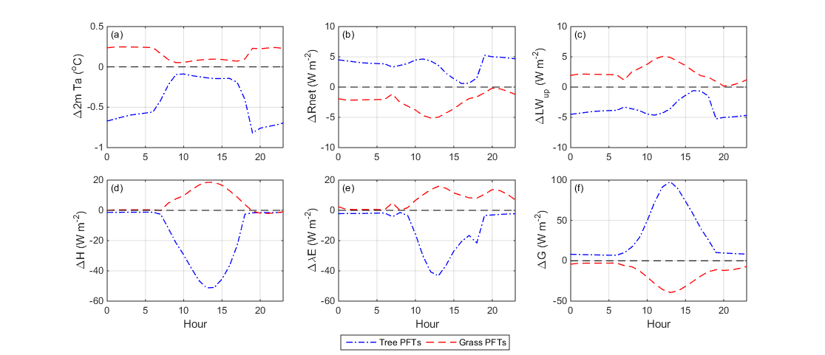
Figure S7b. The hourly differences of (a) 2-m air temperature, (b) net radiation, (c) emitted longwave radiation, (d) albedo, (e) sensible heat flux, (f) latent heat flux, and (g) ground heat flux at the tree and grass PFT-level for the tropical grid cell (6.13ºN, 288.75ºE). The hourly differences are averaged over one year (2010).

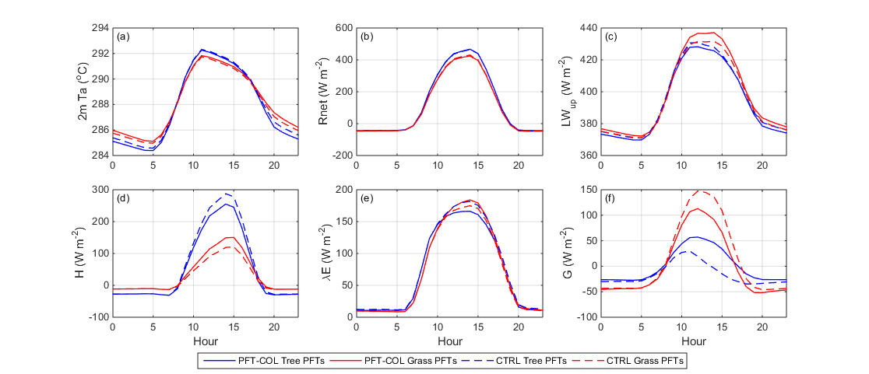
Figure S8a. Same as Figure S3a, but for the temperate grid cell (35.34ºN, 282.5ºE).

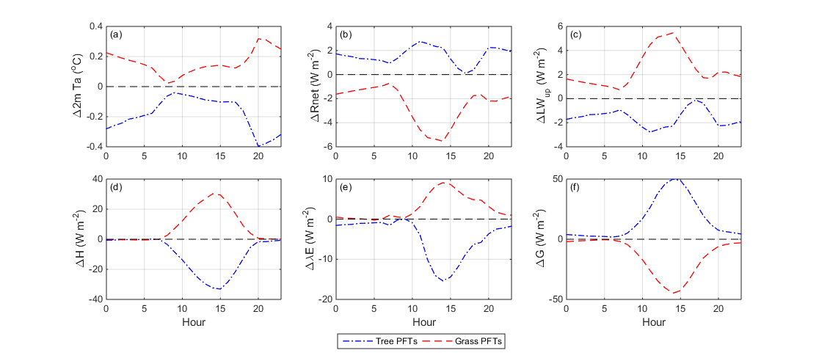
Figure S8b. Same as Figure S3b, but for the temperate grid cell (35.34ºN, 282.5ºE).

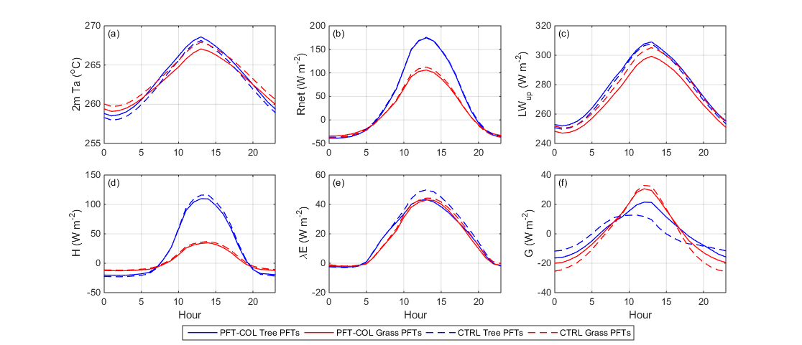
Figure S9a. Same as Figure S3a, but for the boreal grid cell (66.44ºN, 222.5ºE).

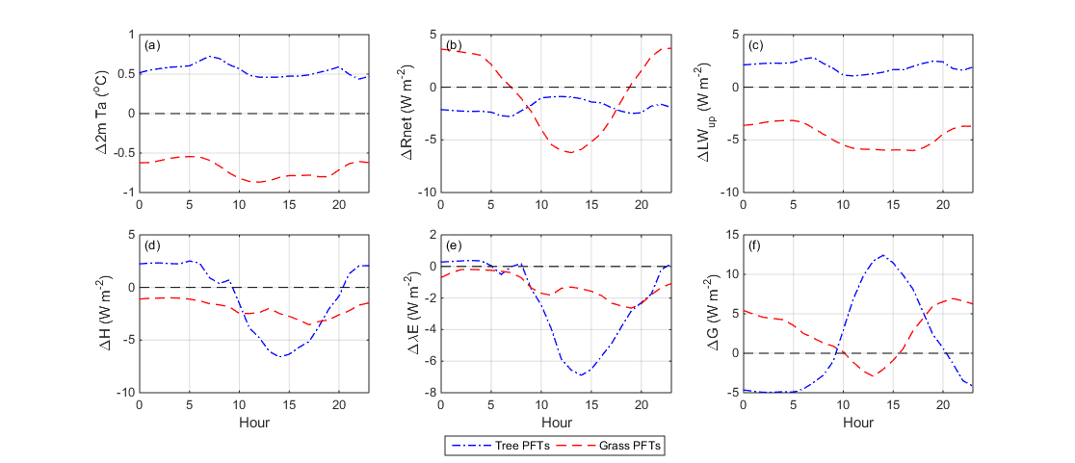
Figure S9b. Same as Figure S3b, but for the boreal grid cell (66.44ºN, 222.5ºE).

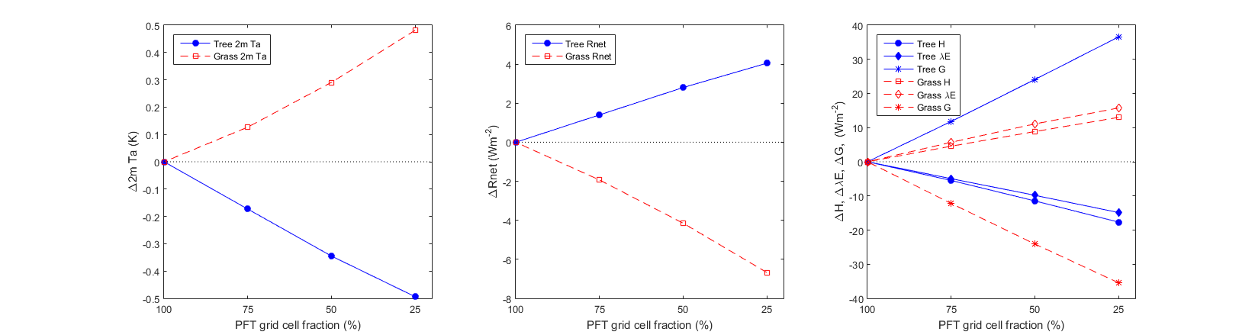

Figure S10. The difference in air temperature, net radiation, sensible, latent, and ground heat fluxes between the PFTCOL and CTRL simulations as a function of PFT grid cell percentage. Single point simulations were run on the tropical grid cell, with PFT fractions for grass (C4 grass) and tree (broadleaf evergreen) fractions ranging between 25 and 100%. At 100% PFT fraction, the CTRL case PFTs equaled the PFTCOL case PFTs. The differences increased as the fraction decreased.

Plant functional type | Boreal | Temperate | Tropical
Bare | 0.016 | 0 | 0.004
Needleleaf evergreen, temperate | 0 | 0.308 | 0
Needleleaf evergreen, boreal | 0.241 | 0 | 0
Needleleaf deciduous, boreal | 0 | 0 | 0
Broadleaf evergreen, tropical | 0 | 0 | 0.241
Broadleaf evergreen, temperate | 0 | 0 | 0
Broadleaf deciduous, tropical | 0 | 0 | 0.062
Broadleaf deciduous, temperate | 0 | 0.152 | 0
Broadleaf deciduous, boreal | 0.004 | 0 | 0
Broadleaf evergreen shrub, temperate | 0 | 0 | 0
Broadleaf deciduous shrub, temperate | 0 | 0.001 | 0
Broadleaf deciduous shrub, boreal | 0.410 | 0 | 0
C3 arctic grass | 0.328 | 0 | 0
C3 non-arctic grass | 0 | 0.190 | 0
C4 grass | 0 | 0.099 | 0.685
C3 generic crop | 0 | 0.247 | 0.008

Table S1. The fraction of PFTs in each of the three grid cells examined in this study.

