Journal of Geophysical Research – Atmospheres
Supporting Information for
Response of surface temperature to afforestation in the Kubuqi Desert, Inner Mongolia
Liming Wang^{1,3,4}, Xuhui Lee^{2,3*}, Natalie Schultz³, Shiping Chen⁵, Zhongwang Wei^{2,3}, Congsheng Fu^{2,3}, Yunqiu Gao^{2,3}, Yanzheng Yang^{1,4}, Guanghui Lin^{1*,4}

¹Ministry of Education Key Laboratory for Earth System Modeling, Department of Earth System Science, Tsinghua University, Beijing 100084, China;
²Yale-NUIST Center on Atmospheric Environment, Nanjing University of Information Science and Technology, Nanjing 210044, China
³School of Forestry and Environmental Studies, Yale University, New Haven, Connecticut 06511, USA.
⁴Division of Ocean Science and Technology, Graduate School at Shenzhen, Tsinghua University, Shenzhen 518055, China
⁵State Key Laboratory for Vegetation Ecology, Institute of Botany, Chinese Academy of Sciences, Beijing, 100093, China

Contents of this file

Text S1
Figures S1 to S14
Tables S1
Table S2

Introduction
In this supplement, we provide additional information on our methods and supplementary figures to support the conclusions in the main text. The Mathematical details of the DTM theory are discussed in Text S1. Parameters and radiometric resistance (r_{r}) calculation in the IBPM prognostic model are provided in Tables S1. We include 14 figures (Figures S1-S14) that illustrate the partitioning results and regression relationship between surface temperature changes calculated by metrics and the observed values under different scenarios.

Text S1.
Mathematical details of the DTM theory
According to the Taylor expansion and omitting higher order terms, we have
${T_{s}^{'}}^{4}≈T_{s}^{4}+4T_{s}^{3}\left(T_{s}^{'}-T_{s}\right)$ (S1)
Mathematically, the surface temperature perturbation can be expressed as,
$$∆T_{s}=T_{s}^{'}-T_{s}≈\frac{1}{4T_{s}^{3}} \left({T_{s}^{'}}^{4}-T_{s}^{4}\right)$$
$$=\frac{1}{4σT_{s}^{3}} \left(σ{T_{s}^{'}}^{4}-σT_{s}^{4}\right)$$
$=λ_{0}[∆S+∆L_{↓}-(∆S+∆L_{↓}-(σ{T_{s}^{'}}^{4}-σT_{s}^{4})]$ (S2)
The ΔT_{s} is the temperature of the open shrubland minus the temperature of the plantation forest (here and hereafter). Using the constraint of energy balance,
$R_{n}=S+L_{↓}-σT_{s}^{4}=LE+H+G$ (S3)
Eq. (S2) becomes
$ΔT_{s}=λ_{0}[ΔS+ΔL_{↓}-ΔR_{n}]$ (S4)

Eq. (S4) can be further written as
$∆T_{s}=λ_{0}[∆S+∆L_{↓}-∆LE-∆H-$ $∆G]$
$=λ_{0}∆S+λ_{0}∆L_{↓}-λ_{0}(∆LE+∆H)-λ_{0}∆G$ (S5)

Eq. (S5) indicates that if the observed fluxes satisfy the energy balance equation, the sum of the component contributions from individual biophysical factors should match exactly the surface temperature perturbation determined with the outgoing longwave radiation flux.

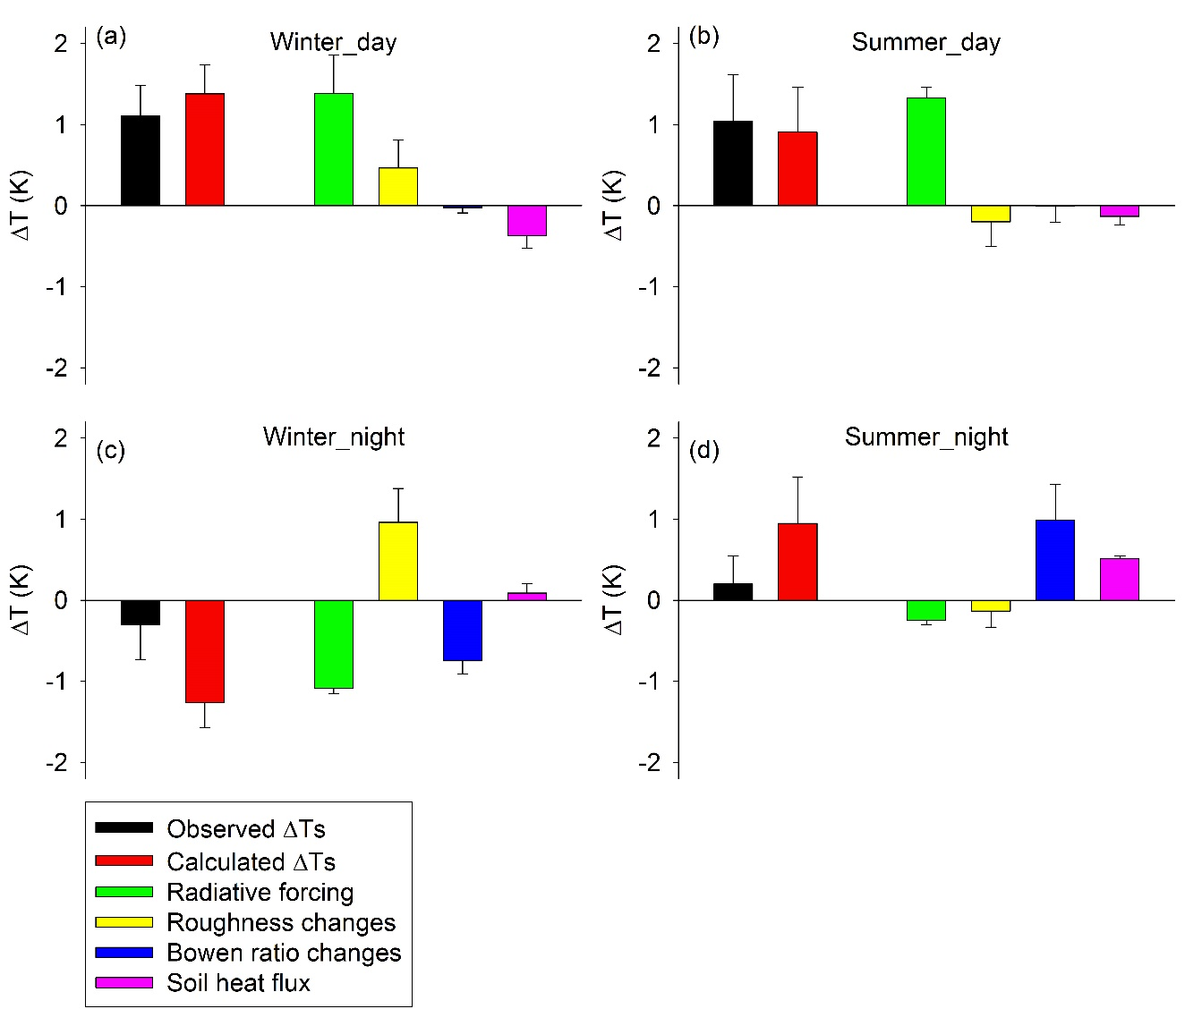
Figure S1. Partition of the biophysical effect in winter and summer in 2008 using the IBPM theory. Error bars are given as 1 SE. Black bars denote observed ΔT_{s}, red bars denote the ΔT_{s} calculated by the IBPM theory, green bars denote radiative forcing, yellow bars denote energy distribution associated with changes in roughness, blue bars denote energy distribution associated with changes in Bowen ratio, pink bars denote the soil heat flux change. The ΔT_{s} is the temperature of the open shrubland minus the temperature of the plantation forest (here and hereafter)
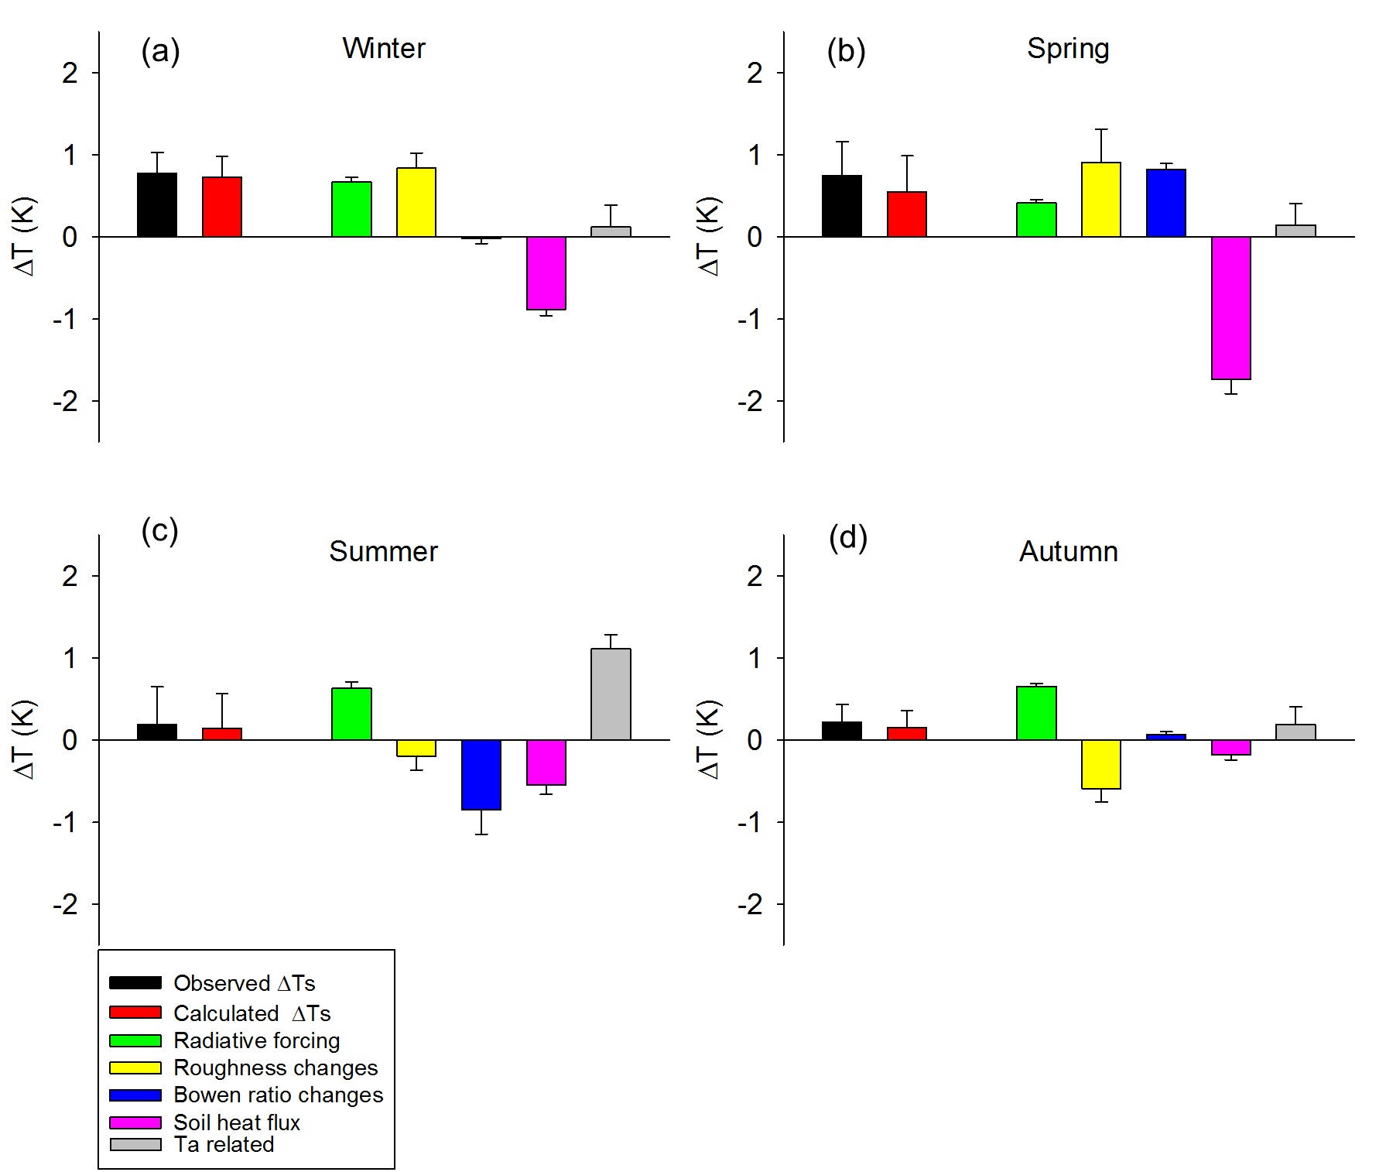Figure S2. Partition of the daytime biophysical effect using the IBPM theory without distribution of air temperature changes into other terms. Error bars are given as 1 SE. Black bars denote observed ΔT_{s}, red bars denote the ΔT_{s} calculated by the IBPM theory, green bars denote radiative forcing, yellow bars denote energy distribution associated with changes in roughness, blue bars denote energy distribution associated with changes in Bowen ratio, pink bars denote the soil heat flux changes and grey bars denote the term related to air temperature changes.

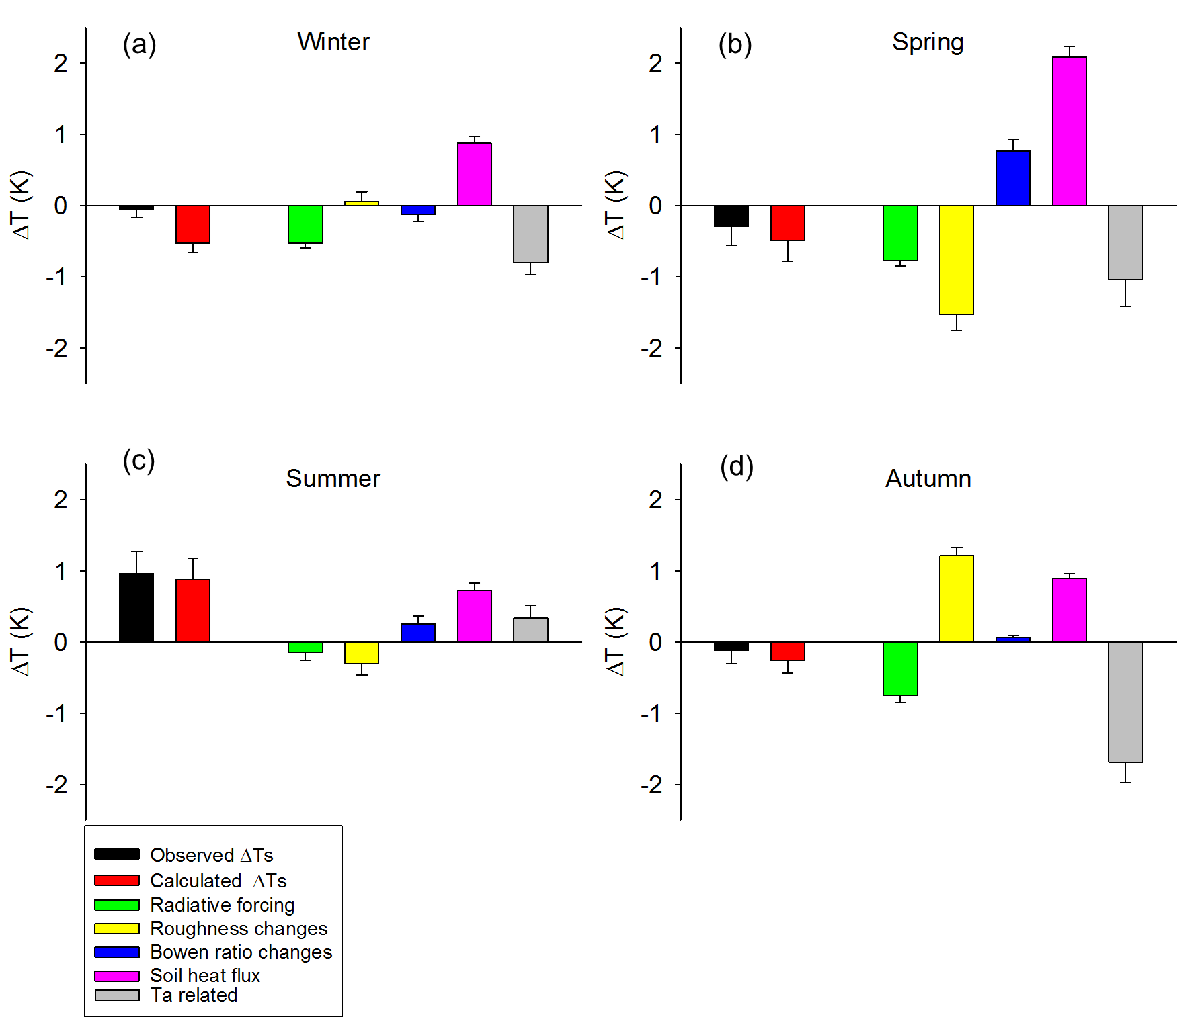
Figure S3. Same as Figure S2 except for nighttime.

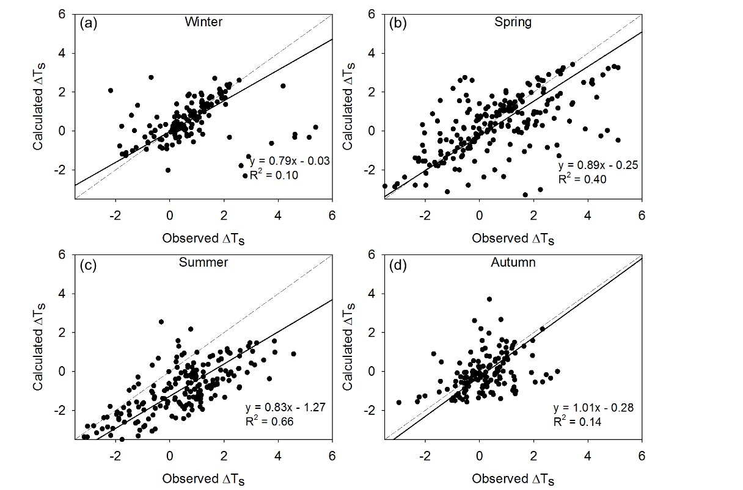
Figure S4. The relationship between the daytime half-hourly ΔT_{s} calculated by the IBPM theory and the observed ΔT_{s}. Here Term 5 in Eq. (14) has been omitted. The regression equations and determination coefficients (R²) were calculated with the geometric mean regression method. The dash lines represent the 1:1 line and the solid lines represent the regression results.

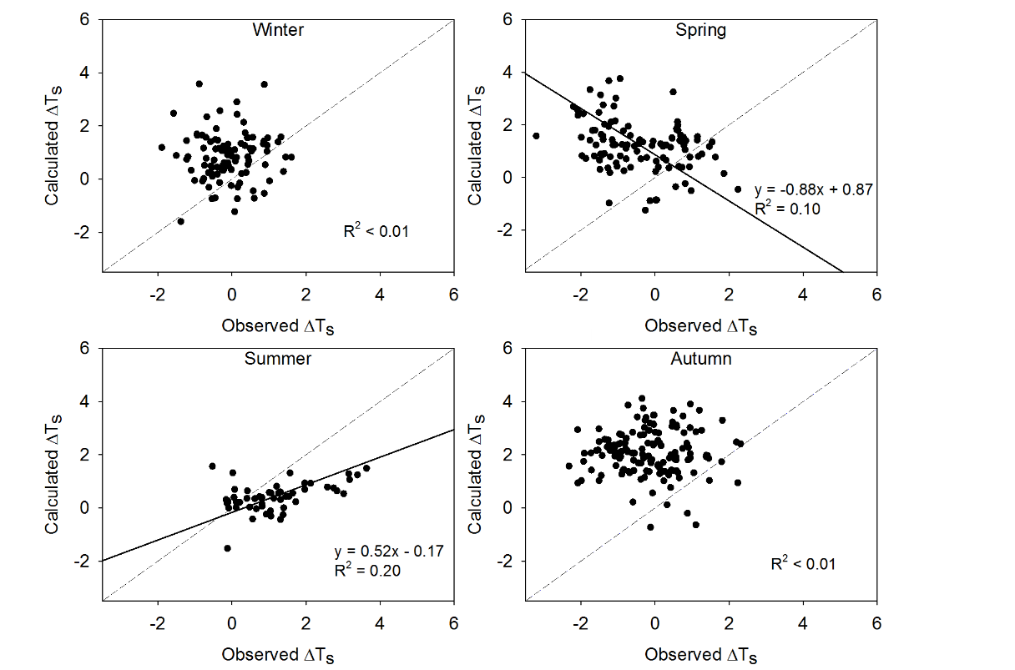
Figure S5. Same as Figure S4 except for nighttime.

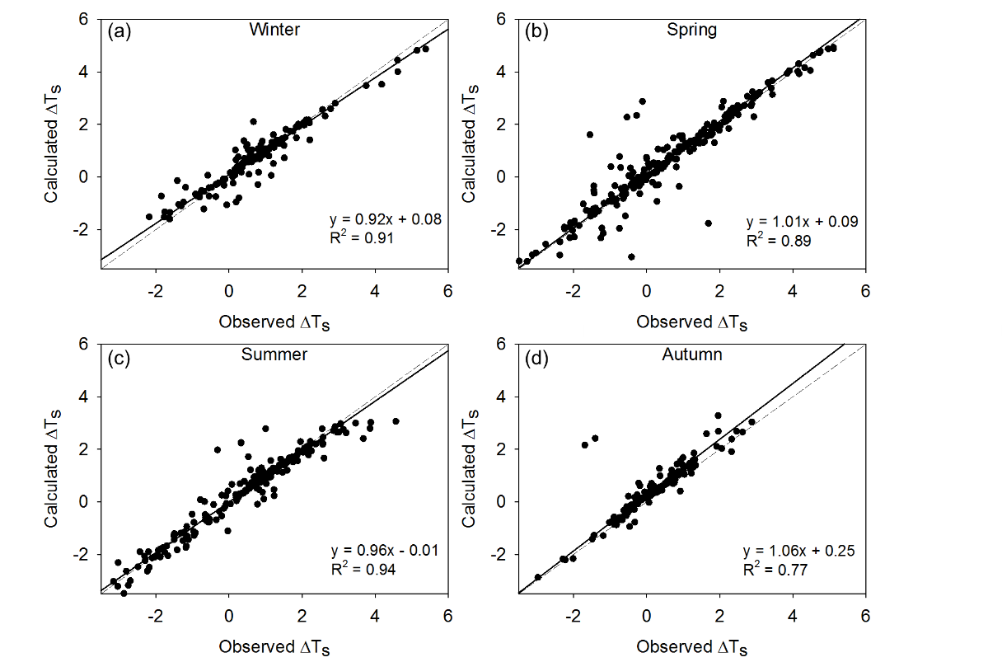
Figure S6. The relationship between the daytime half-hourly ΔT_{s} calculated by the IBPM theory and the observed ΔT_{s}. Here the term $\frac{λ_{0}}{1+f}$ΔL↓ in Eq. (14) has been omitted. The regression equations and determination coefficients (R²) were calculated with the geometric mean regression method. The dash lines represent the 1:1 line and the solid lines represent the regression results.

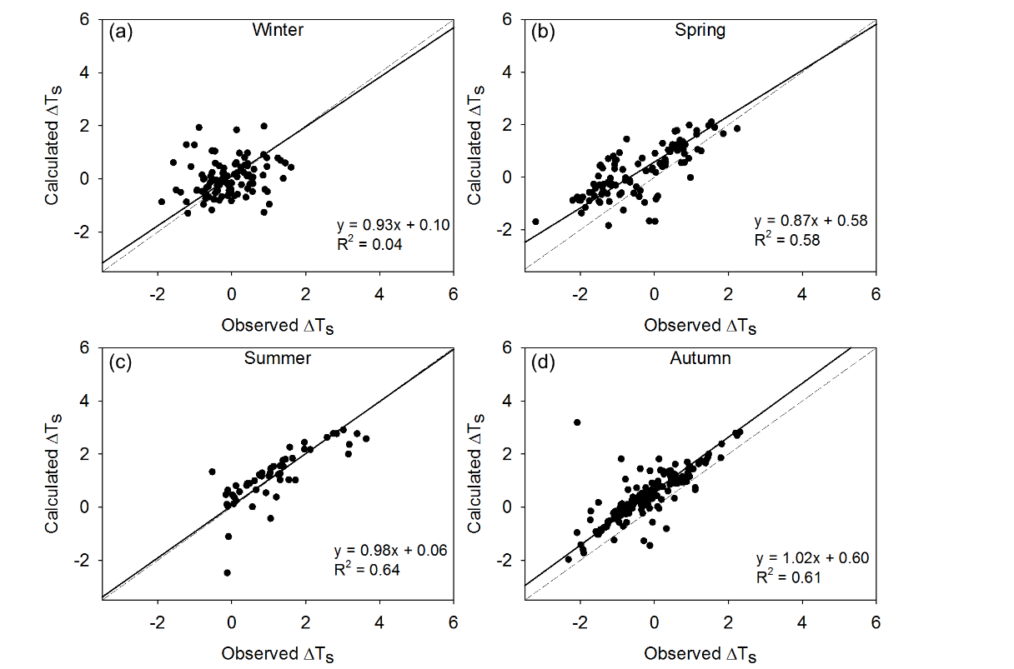
Figure S7. Same as Figure S6 except for nighttime.

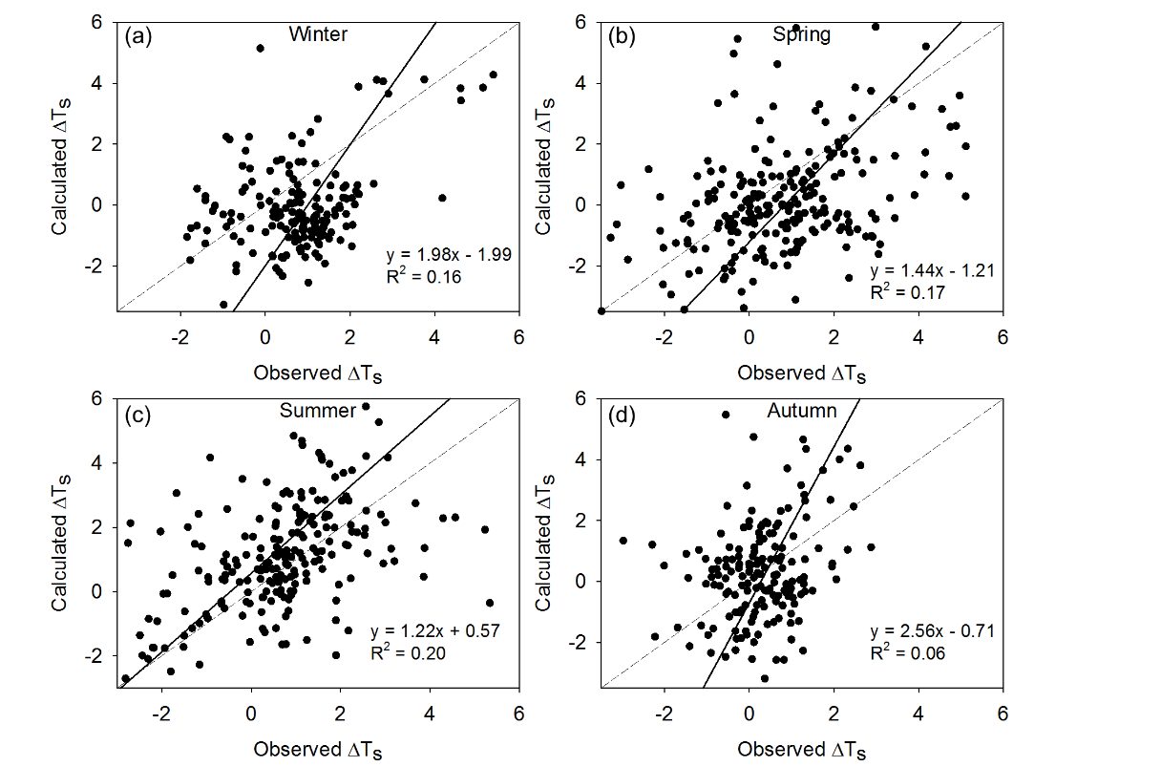
Figure S8. The relationship between the daytime half-hourly ΔT_{s} calculated by the prognostic IBPM model and the observed ΔT_{s}. The regression equations and determination coefficients (R²) were calculated with the geometric mean regression method. The dash lines represent the 1:1 line and the solid lines represent the regression results.

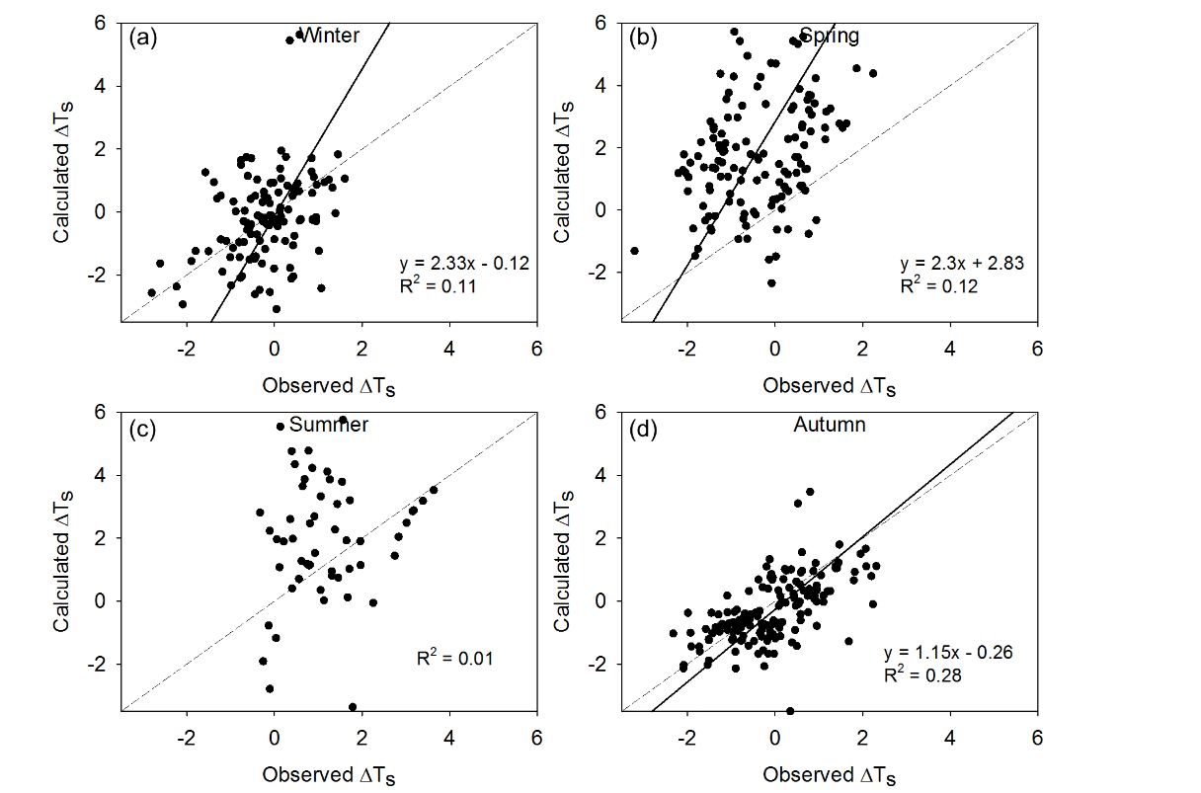
Figure S9. Same as Figure S8 except for nighttime.

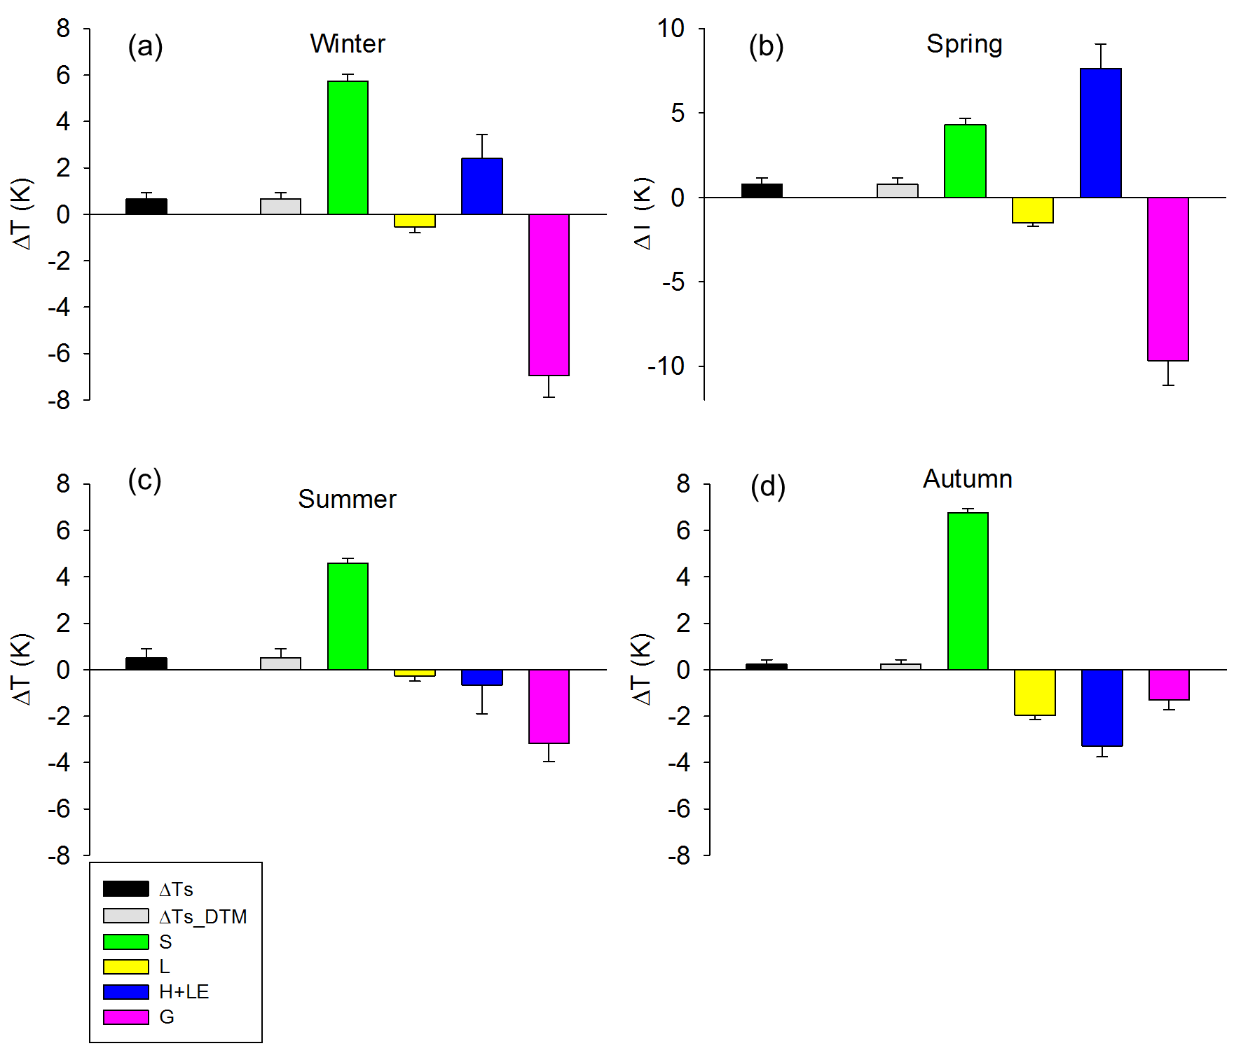
Figure S10. Partition of the daytime biophysical effects by the DTM theory. Error bars are given as 1 SE. Black bars denote observed ΔT_{s}, grey bars denote the ΔT_{s} calculated by the DTM theory, green bars denote shortwave radiative forcing, yellow bars denote incoming longwave radiation changes, blue bars denote sensible heat and latent heat changes, and pink bars denote the soil heat flux changes.

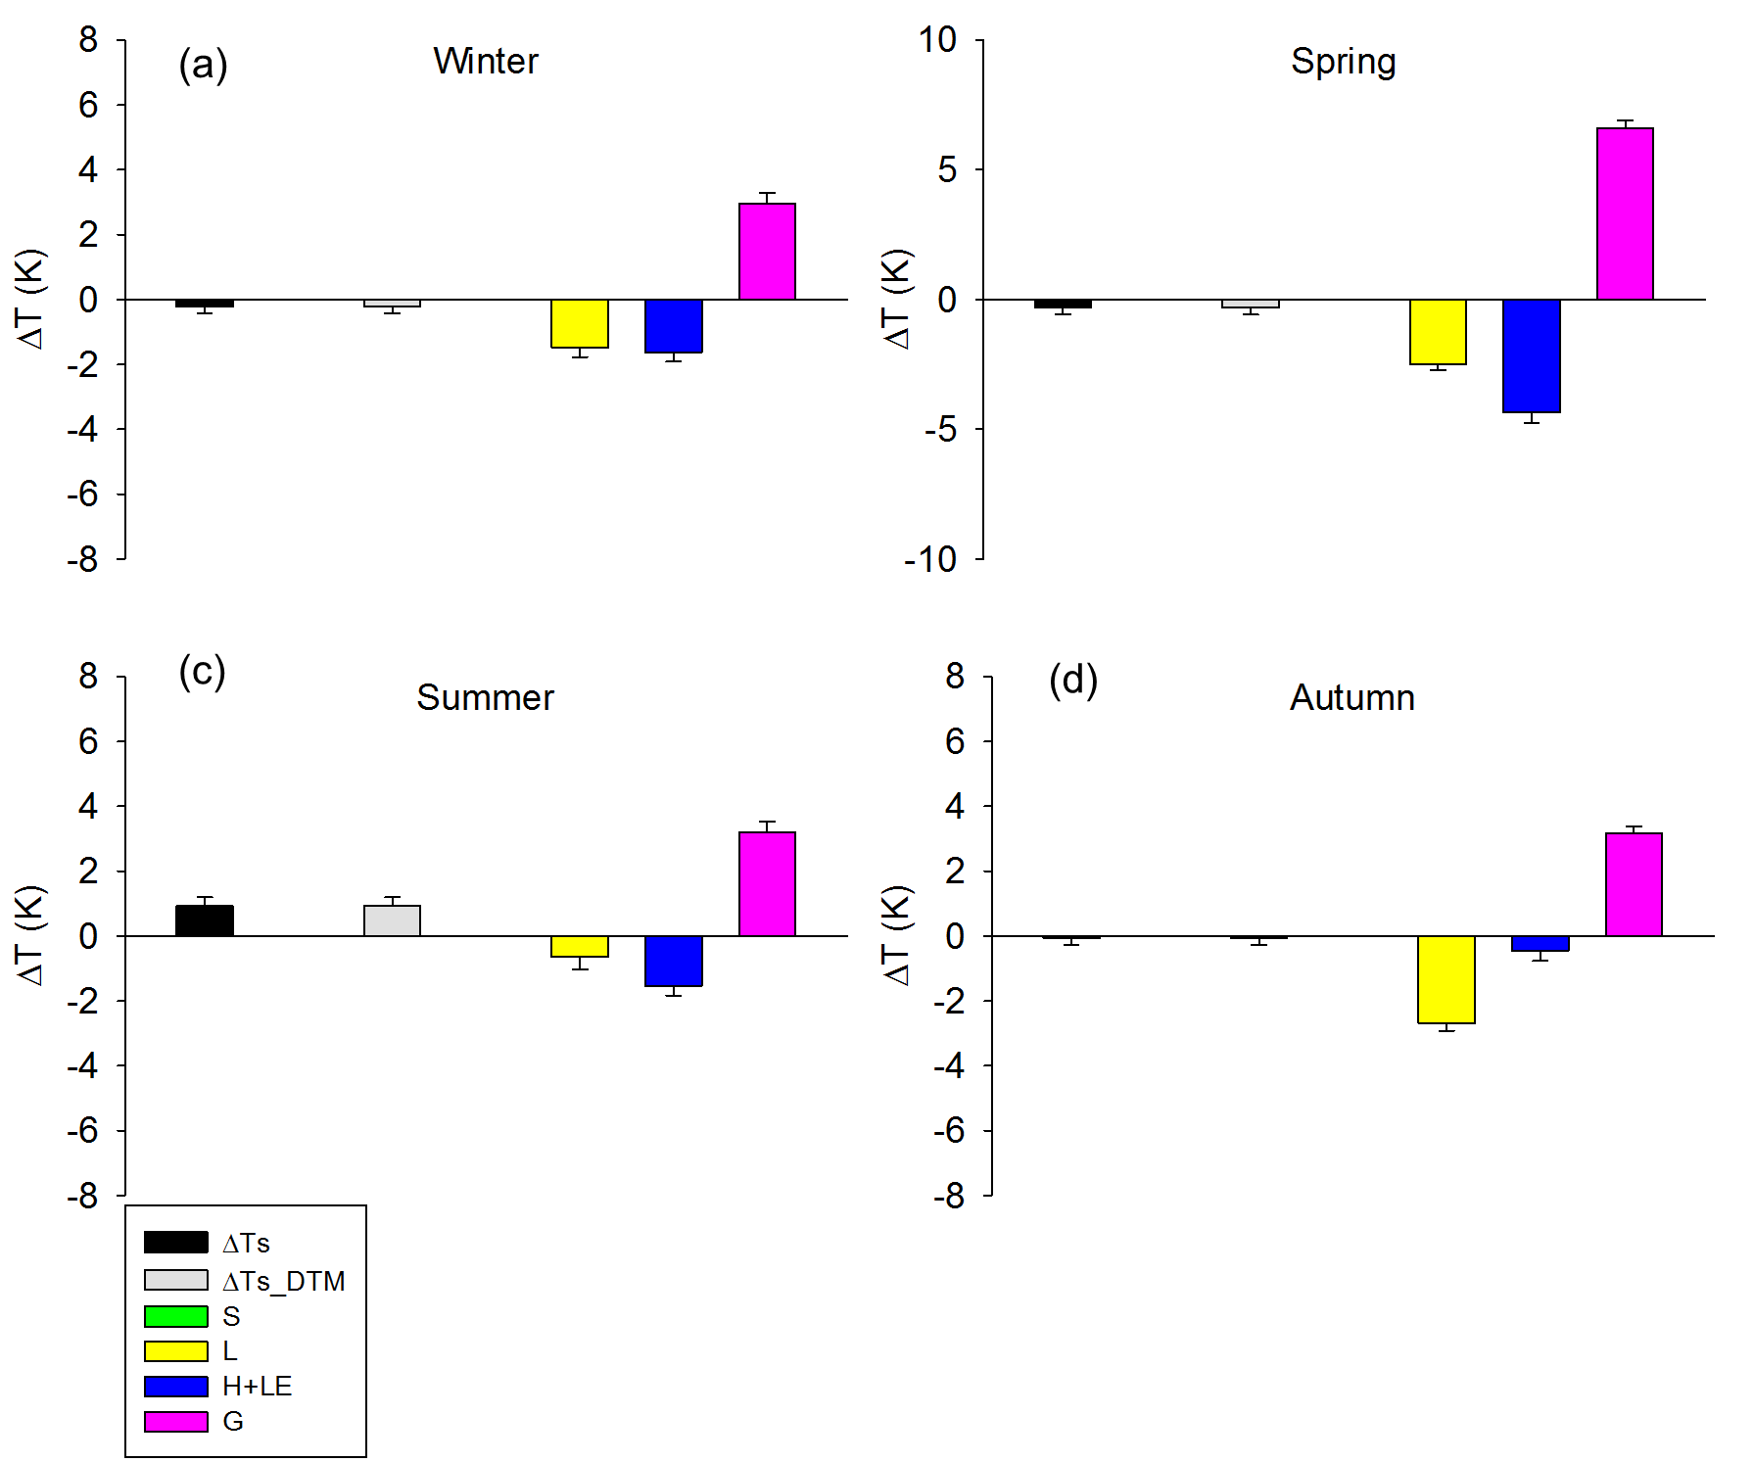
Figure S11. Same as Figure S10 except for nighttime.

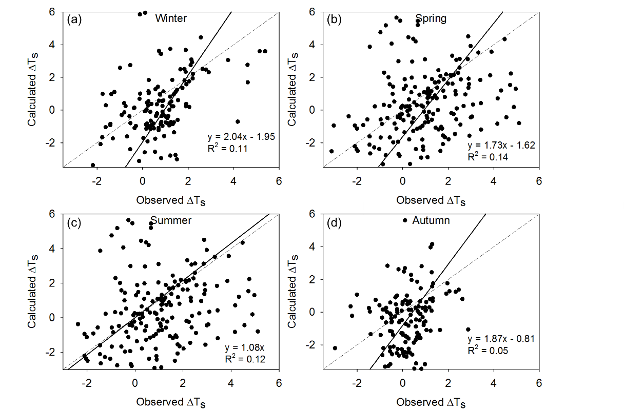
Figure S12. The relationship between daytime half-hourly ΔT_{s} calculated by the IBPM theory and the observed ΔT_{s} under energy imbalance conditions. The regression equations and determination coefficients (R²) were calculated with the geometric mean regression method. The dash lines represent the 1:1 line and the solid lines represent the regression results.

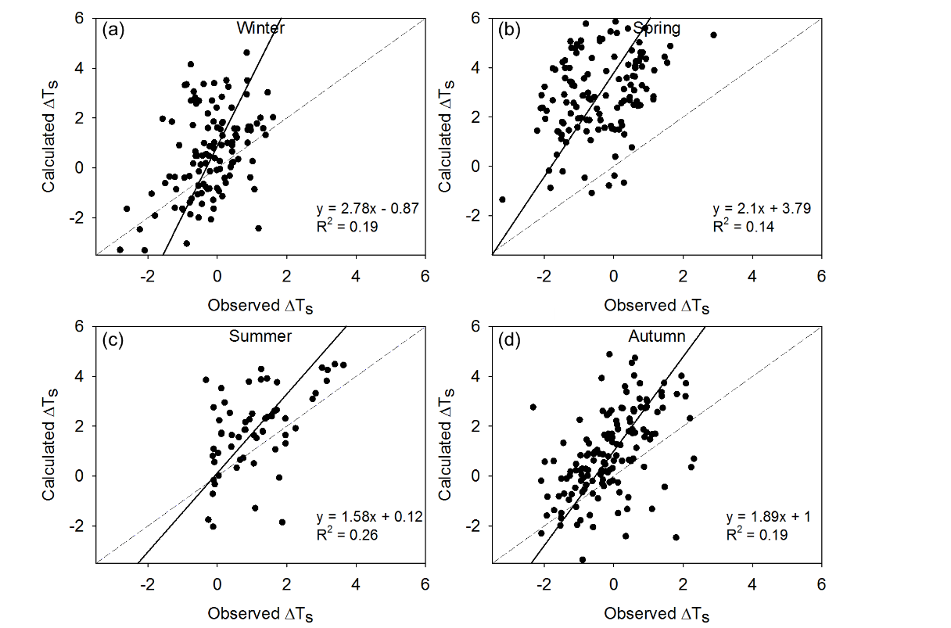
Figure S13. Same as Figure S12 except for nighttime.

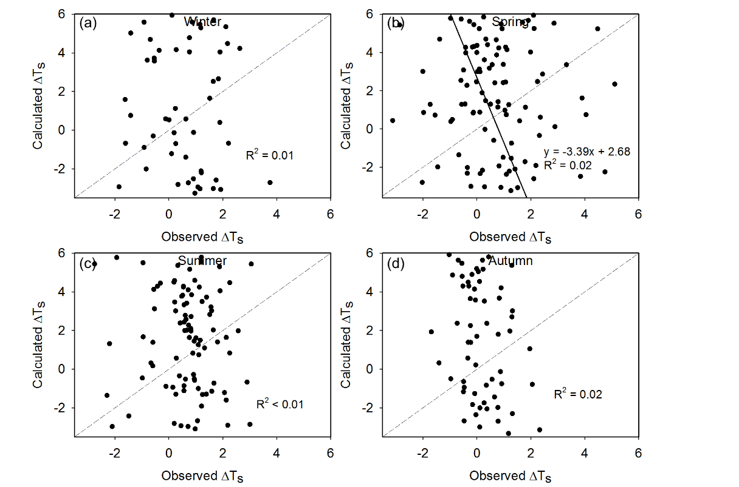
Figure S14. The relationship between daytime half-hourly ΔT_{s} calculated by the DTM theory and the observed ΔT_{s} under energy imbalance conditions. The regression equations and determination coefficients (R²) were calculated with the geometric mean regression method. The dash lines represent the 1:1 line and the solid lines represent the regression results.

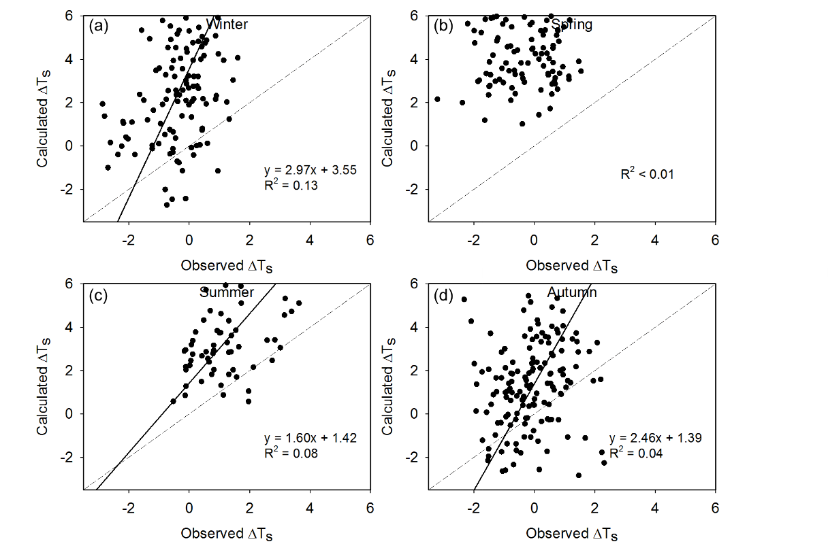
Figure S15. Same as Figure S14 except for nighttime.

Table S1. Parameters and radiometric resistance (r_{r}) calculation in the IBPM prognostic model. z is the measurement height of air temperature and wind speed, d is the displacement height, z₀ is the aerodynamic roughness length, z_{h} is the thermal roughness length, LAI is leaf area index and DOY is day of year.

 | Forest | Shrubland
z (m) | 10 | 4
d (m) | 2.1 | 0.35
z₀ (m) | 0.3 | 0.05
z_{h} (m) | 0.041 | 0.007
r_{r} day (60≤DOY≤240, s m⁻¹) | 24.4exp(−0.5LAI) | 24.4exp(−0.5LAI)
r_{r} day (DOY<60, DOY>240, s m⁻¹) | 14.9exp(−0.2LAI) | 14.9exp(−0.2LAI)
r_{r} night (s m ⁻¹) | 0.0049DOY² −1.96DOY+258 | 0.0011DOY² −0.6726DOY+172

Table S2. The mean values of the predicted aerodynamic resistance (r_{a}), excess resistance (r_{ex}) and radiometric resistance (r_{r}).
Site | Day or night | r_{a} | r_{ex} | r_{r}
Shrubland | Daytime | 15 ± 1.6 | 10.5 ± 0.8 | 18.2 ± 2.1
 | Nighttime | 11 ± 0.2 | 12.3 ± 0.4 | 96.8 ± 16.1
Forest | Daytime | 23.4 ± 3.5 | 11.3 ± 1.3 | 17.9 ± 1.9
 | Nighttime | 11.8 ± 1.1 | 9.9 ± 0.7 | 108.4 ± 23.8

Table S3. The mean value of energy redistribution factor (f).
 | 24-hour |  | Daytime |  | Nighttime
Season | Forest | Shrub | Forest | Shrub | Forest | Shrub
Winter | 4.5 | 5.0 | 7.6 | 8.0 | 1.2 | 1.6
Spring | 4.3 | 5.1 | 6.2 | 7.2 | 1.7 | 2.1
Summer | 4.1 | 4.4 | 5.3 | 5.6 | 1.6 | 1.3
Autumn | 4.6 | 4.7 | 6.1 | 5.9 | 1.5 | 1.7
Total | 4.4 | 4.8 | 6.3 | 6.7 | 1.5 | 1.7

